GRADUATE THESIS/DISSERTATION FORMAT TEMPLATE
national university of sciences and technology
islamabad
Version: ms1.0; Dated: 27Apr 2023


Template of Graduate Thesis/Dissertation is an “essential kit” to format thesis in Microsoft Word. This template has Word’s auto-generate capability and facilitate incorporation of automatic List of Tables, List of Figures and Table of Contents, and numbering of equations.

Thesis template and guidelines assists to provide correct formatting of following:
correct page numbering, margins, the front pages format, chapter headings, section headings, and subheading styles set up to level 3.

Furthermore, there are help boxes provided as Blue Text Boxes to explain the formatting. These boxes need to be deleted before the printing of thesis. These boxes can be easily deleted by viewing under View menu and Print Layout to see or delete these Blue text.

It is advised that this template should be used as a starting point to format the thesis, with further assistance can be obtained from Supervisor, Exam cell and Students for proper formatting.

[DELETE THIS PAGE BEFORE BEGINNING]

Thesis Title Goes Here Center [Doping Graphene Sheets]
[Times New Roman, Bold, Font Size 16]
NUST Logo size
45 mm


By
Student Name
(Registration No: 00000123456)

Department of Materials Engineering
School of Chemical and Materials Engineering
National University of Sciences & Technology (NUST)
Islamabad, Pakistan
(2023)
Thesis Title Goes Here Center
[Times New Roman, Bold, Font Size 16, Center]

By
Student Name
(Registration No: 00000123456)
A thesis submitted to the National University of Sciences and Technology, Islamabad,
in partial fulfillment of the requirements for the degree of
Master of Science in
Materials Engineering
Supervisor: Dr.
Co Supervisor (if any): Dr.

School of Chemical and Materials Engineering
National University of Sciences & Technology (NUST)
Islamabad, Pakistan
(2023)
THESIS ACCEPTANCE CERTIFICATE
Certified that final copy of MS Thesis written by Mr / Ms (Registration No. ), of (School/College/Institute) has been vetted by undersigned, found complete in all respects as per NUST Statutes/ Regulations/ Masters Policy, is free of plagiarism, errors, and mistakes and is accepted as partial fulfillment for award of Masters degree. It is further certified that necessary amendments as point out by GEC members and evaluators of the scholar have also been incorporated in the said thesis.

Signature:
Name of Supervisor
Date:

Signature (HOD):
Date:

Signature (Dean/ Principal)
Date:
TH - 4 Form Goes Here
AUTHOR’S DECLARATION
I Shawana Faz hereby state that my MS thesis titled “ A Complementary Vision Transformer and CNN Fusion Framework with Faithful Explainability for Breast Cancer Histopathology ” is my own work and has not been submitted previously by me for taking any degree from National University of Sciences and Technology, Islamabad or anywhere else in the country/ world.
At any time if my statement is found to be incorrect even after I graduate, the university has the right to withdraw my MS degree.

Name of Student: Shawana Faz
Date:

ACKNOWLEDGEMENTS
I begin by expressing my humility and thanks to Allah Almighty, who gave me the capability and resilience to undertake and complete this research.
I am profoundly indebted to my supervisor, Dr. Arbab Latif. His thoughtful direction, consistent encouragement, and depth of knowledge were crucial at every step of this work. I have learned immensely under his mentorship.
My sincere appreciation goes to my GEC members Dr. Muhammad Khuram Shahzad, Dr. Wajid Mumtaz, and Dr. Shehzad Yunis. I value their time, critical input, and support throughout this process. I also acknowledge Principal Dr. Muhammad Ajmal Khan and SEECS for cultivating an academic setting that enabled me to grow during my Master’s program.
To my parents, I owe more than words can capture. Their love, sacrifices, and trust in me have been the bedrock of every milestone I have reached. I also want to recognize Aleena Aslam (SEECS student) and Eesha Umer (SEECS class fellow) for their friendship, encouragement, and for keeping me grounded when this journey felt overwhelming.

TABLE OF CONTENTS
aCKNOWLEDGEMENTS viii
TABLE OF CONTENTS ix
LIST OF TABLES x
LIST OF FIGURES xi
LIST OF SYMBOLS, ABBREVIATIONS and acronyms xii
aBSTRACT xiii
chapter 1: Introduction 1
1.1 How to Use This Template [This is a First-Level Subheading] 1
1.1.1 This is a Second-Level Subheading 1
1.1.2 Inserting and Numbering Equations 1
1.1.3 Inserting, Numbering, and Referencing Figures 2
1.1.4 Inserting, Numbering, and Referencing Tables 3
1.1.5 Things to be Careful of 4
CHAPTER 2: Setting up a new chapter 6
2.1 Moving to a New Chapter 6
2.1.1 How to Insert a Page Break 6
SUMMARY of Research work 7
Chapter 3: CONCLUSIONS and FUTURE RECOMMENDATION 8
REFERENCES 9
APPENDIX A: DESCRIPTION OF DEFAULT SUBHEADING SCHEME 10
A.1 First-Level Subheading 10
A.1.1 Second-Level Subheadings 10
LIST OF PUBLICATIONS 12

LIST OF TABLES
Page No.
Table 1.1: Example of a table 3

By utilizing Word’s “Insert Caption…” feature, you can easily build your List of Tables (this page) and List of Figures (following page).

To insert list of table and figures, click at reference tab > insert Table and figures
To update all fields prior to submitting your document, simply select the table, right click the text, and select “Update Field.”

DELETE THIS INSTRUCTIONS TEXT BOX BEFORE PRINTING.

LIST OF FIGURES
Page No.
Figure 1.1: This is a figure. The “caption” uses the “Caption” theme from the quick styles menu above and is added by right-clicking the figure and selecting “Insert Caption...” 2
Figure 1.2: Example of a Figure 3
The list of figures uses the captions as they appear below the figures in the text. If captions are very long, they may be truncated in the list of figures.

DELETE THIS INSTRUCTIONS TEXT BOX BEFORE PRINTING.

LIST OF SYMBOLS, ABBREVIATIONS and acronyms
A | the letter A
B | the letter B
CGS | Center for Graduate Studies
Common symbols, such as scientific fonts, may be used in the body of the thesis, but not in the title of the work. Thesis or dissertation titles containing formulas, symbols, superscripts, Greek letters, or other nonalphabetical symbols should use word substitutes for those symbols (e.g., “Gamma Ferric Oxide Dispersion…,”“…Alpha- and Beta- Globulin…,”“…The Neodymium-Barium-Copper Oxide System.…”)
Other names of lists can be acceptable to the department or Insittion may be allowed upon approval of GEC.
DELETE THIS INSTRUCTIONS TEXT BOX BEFORE PRINTING.

ABSTRACT
Computer-aided diagnosis for breast histopathology requires models that are both accurate and interpretable. Vision Transformers capture global stromal architecture while CNNs capture local nuclear morphology, suggesting fusion should improve performance. However, explainability for fusion architectures remains unsolved because Class Activation Maps assume linear final layers.This thesis investigates feature-level fusion of Swin-B and ConvNeXt-B on BreakHis 400X images. Features are concatenated, standardized, and classified by a frozen-backbone MLP. The fusion model achieves binary F1=0.9885, balanced accuracy=0.9823, MCC=0.9647, and ECE=0.0605, outperforming single models by 2.1% F1 and reducing error rate by 61%. 8-class macro-F1 reaches 0.8747, confirming granularity.For explainability, we show additive CAM composition fails with AUC-DEL=0.551 on fusion, worse than the 0.50 random baseline. We implement Integrated Gradients on the end-to-end wrapper, which respects the nonlinear MLP and satisfies the Completeness axiom. IG achieves AUC-DEL=0.176 on fusion, a 68% improvement over additive CAM and 2.6× better than GradCAM++ at 0.4618. Benchmarking five methods on n=30 images confirms IG uniquely succeeds; all CAMs fail AUC-DEL>0.46 for fusion. To explain fusion gains, we decompose branches via masked IG. Median IoU between Swin and ConvNeXt saliency is 0.051, indicating 95% spatial disjointness. Branch disagreement IoU<0.15 correlates with misclassifications, enabling error flagging. The method requires 0.33s per image, acceptable for offline clinical review.
Keywords: Histopathology, Swin Transformer, ConvNeXt, Feature Fusion, Integrated Gradients, Explainable AI, Faithfulness, AUC-DEL

Chapter 1: Introduction
Breast cancer is still one of the major causes of cancer death in women globally, and early and accurate diagnosis is important. The gold standard for diagnosis and treatment planning is performed on hematoxylin and eosin (H&E) stained tissue slides. Manual review, however, is labor intensive and can be inconsistent in subtle morphological patterns or in rare subtypes. The diagnostic need keeps growing and there is a shortage of trained pathologists; tools for decision making are needed that offer consistent, reliable and transparent analysis.
Medical image analysis has been revolutionized by deep learning. In histopathology, Convolutional Neural Networks (CNNs) are known for their ability to learn hierarchical features directly from image data which is why they perform well in this field. However, CNNs have a tendency to be local texture-sensitive and struggle to capture long-range stromal architecture that contributes to malignancy. Furthermore, they have opaque decision processes which reduce clinical trust. Self-attention mechanisms modelling global context have recently demonstrated success in the field of Vision Transformers, for instance, in the Swin Transformer. This is very significant in Histopathology where there are diagnostic clues across multiple areas of tissues. Despite this, the comparison of transformers with more recent CNNs for breast histopathology remains scarce and little is known about why they are complementary.
There are three barriers to clinical deployment. Variability in data first is due to differences in staining, scanners, and labs which reduces generalization. Preprocessing should retain clinically relevant features and be robust. Second, model selection: it is not yet clear if the transformers work better than the CNNs, or if a fusion of both architectures enables to achieve better results by combining local and global representations. Third, interpretability: Explainable AI techniques try to visualize model reasoning, like Grad-CAM, Grad-CAM++, and Integrated Gradients. But with little annotation it is hard to validate these explanations and quantitative evaluation of faithfulness is rarely done. In the case of fusion architectures, it is impossible to use standard attribution methods because the composition of the activation maps is non-linear.
This thesis contributes to overcome these gaps in three ways. First, we apply and test the fusion of Swin Transformer and ConvNeXt, a current re-modelled CNN, to the BreakHis 400X dataset. We demonstrate that frozen-backbone fusion can be used to improve the calibration ECE to 0.0605 and achieve balanced accuracy=0.9823 and MCC=0.0647 with error reduction of 61% compared with the single models. Second, we show that attribution faithfulness of Additive CAMs is sub-optimal for nonlinear fusion (AUC-DEL=0.551, which is below random chance) To solve this, we employ the Integrated Gradients method to the end-to-end fusion model, resulting in the AUC-DEL value of 0.176, which is a 68% relative improvement. Third, we give mechanistic insight by decomposing the branches according to masked IG, which shows 95% of spatial disjointness between branches, median IoU=0.051, meaning that branches tend to attend to different tissue regions. This is why branches can agree on fusion gains and error flagging is possible if their branches disagree.
This work brings together the key components of rigorous evaluation, architecturally faithful explainability, and quantitative analysis of model behavior that will lead to AI tools which are not only high-performing but also clinically meaningful and auditable. The aim is to translate benchmarks for machine learning into the needs of clinical decision making.

1.1 Problem Statement
The breast histopathology classification with deep learning is limited by three challenges:
Scarcity of data, patient level generalization: BreakHis images cover <2000 images from <100 patients. When finetuning is performed on the whole backbone, the CV macro-F1 is even more significantly reduced at the patient level ( > 10pp compared to image-level CV) due to patient identity leakage.
Inefficiency in computation and parameters: The state-of-the-art methods have 88M trainable parameters and need to be finetuned on the full GPU, which is not feasible to use in hospitals or transfer to new magnifications or datasets.
Explainability failure of fusion models: Standard gradient-CAM based methods are mechanically incompatible with non-linear MLP fusion heads that are based on convolutional backbones and generate unfaithful saliency maps and thus fail to gain clinical trust.
Current methods compromise on accuracy by using frozen linear probes, or compromising on efficiency and interpretability through full finetuning. A method to reach SOTA accuracy with <5M trainable parameters, generalizing across patients and providing faithful post-hoc explanations is needed.
The proposed new architecture, which satisfies all three constraints, is created by freezing the heterogeneous backbones alongside expert-gated fusion, and by applying Integrated Gradients to the non-linear fusion head to provide faithful XAI.In this research, a novel architecture is proposed, satisfying all three constraints, by freezing the heterogeneous backbones along with expert-gated fusion, and by applying Integrated Gradients to the non-linear fusion head to obtain faithful XAI.
1.2 Research Objectives
i. Develop lightweight fusion architecture, with <5M trainable parameters, to match or beat the performance of full finetuning on BreakHis 400× 8-class subtyping, using frozen ConvNeXt-Base and Swin-Base features.
ii. To propose a two-head expert model with learned gating to factorise benign/malignant screening and 8-class diagnosis, while reducing CV variance at the patient level when compared to single-head fusion, which is expected to alleviate gradient conflict.
iii. The breakdown of BreakHis 400× was performed and evaluated under strict patient-level 5-fold cross validation, yielding three metrics (pooled macro-F1, binary-F1, AUC) with bootstrap confidence intervals.
iv. To compare the proposed method using paired McNemar tests and ablation studies with six baselines: single-backbone linear probes, logit ensemble, feature-ensemble MLP, binary-optimised fusion, macro-optimised fusion, and partial finetuning.
v. To set up a reliable explainability model for fusion models, using Integrated Gradients instead of Grad-CAM, and proposing a new measurement of backbone spatial disagreement based on IoU analysis.
1.3 Research Motivation
Traditional medical image classification uses end-to-end fine-tuning of ImageNet based models such as the ResNet-50 or DenseNet-201. This paradigm is not applicable on the small clinical dataset, for the following three reasons:
Violation of the data-to-parameter ratio (81 patients and 1,693 images, 88M parameters) leads to a reduction of patient-CV performance by 5–15pp compared to image-CV performance.
Computational cost: Hospitals have no GPU clusters to retrain as the magnification or scanners change. Cached-feature training takes hours down to minutes.
Lack of trust: Clinicians offer rejection of “black box” models. Grad-CAM is not applicable to fusion architectures, so there is no way to validate that predictions are based on the morphology of the tumour and not on stain artifacts.
Frozen feature extraction with linear probes deals with the cost but compromises on 8–12pp accuracy. The difference is due to lack of modeling of complementary information between backbones by linear probes.
The disagreement and cross-model attribution IoU between Cohen (κ=0.679) and Heterogeneous fusion motivation suggest that they agree on different regions. If the fusion mechanism is able to direct inputs to the right expert, then they should recover the lost accuracy by fusing them.
Two sequential decisions by the pathologist: Screening (benign or malignant) and diagnosis (subtype). An 8-class softmax alone does not provide an answer to the screening question. These two specialised heads are used in a manner that is similar to the clinical situation and give interpretable probabilities for both decisions.
With training just 4.27M parameters on cached 2048-D vectors, it can be deployed on CPU-only hospital workstations and adapt in real time to new BreakHis 100×/200×/400× without re-extracting features.

1.4 Research Contributions
We make the following major contributions to this research:
I. New SOTA on BreakHis 400×: The two-head v3.6 model has a pooled macro-F1 of 0.892 (+2.4pp compared with MiSLAS 0.868) with 20× fewer trainable parameters (4.27M vs 88M). It also achieves SOTA of 97.81% accuracy and 0.9901 AUC on binary classification.
II. Medical fusion expert gated: We present a two-head design with learned per-image gating to decrease patient-CV variance by 45% (from 0.1599 to 0.0876) and avoid patient collapse on hard folds. Ablation shows gains are not in the number of parameters.
III. The ablation unfreezing strategy for Swin shows that frozen > finetune empirical proof, where the patient CV is raised from 0.881 to 0.882, close to the noise level, suggesting that frozen features are sufficient when heterogeneous backbones are used. This is opposite to current finetuning guidelines for small medical datasets.
IV. For fusion models: We show that Grad-CAM cannot be mechanically applied to MLP fusion heads, and present a replacement: Integrated Grad-Ints, which gets 3.1× higher deletion-AUC (0.176 vs 0.551). The cross-model IoU analysis shows that the backbones are concentrated in different parts of the tissue indicating the biological specialisation.
V. Complete benchmark and reproducibility: Providing patient-level CV, McNemar tests, bootstrap CIs and per-subclass tables of cached features, training code, and evaluation scripts. Six baselines establish that gains are architectural, not due to training tricks.
The next sections of the research include literature review of histopathology classification, frozen features and fusion method. Chapter 3 provides a detailed description of the proposed two-head architecture, training algorithm and XAI framework. Chapter 4 presents patient-CV results, statistical validation, a few ablations, and explainability analysis. The results and suggestions for future work on the transfer 100×/200×/400× are covered in Chapter 5.

1.5 Summary
This thesis introduces a trustworthy, interpretable and accurate framework for classification of breast histopathology, aiming to solve the critical three problems of accuracy, efficiency and trust in clinical artificial intelligence. For the risk of overfitting from the small dataset, this addresses the issue by freezing both ConvNeXt-Base and Swin-Base features and adding a 4.27M-parameter expert-gated fusion head to achieve patient-CV SOTA of 0.892 macro-F1. In addition, two specialists are integrated into the architecture that are similar to clinical experts and offer calibrated probabilities for screening and diagnosis. The methodology includes thorough 5-fold patient-CV evaluation, paired statistical tests, and symbolic XAI verification by means of Integrated Gradients. Further ablation proves that there is no accuracy loss using freezing vs partial finetuning for backbones. The protocol achieves commendable accuracy, stability, and efficiency, as indicated by performance evaluation with 20× parameter reduction and 3.1× XAI faithfulness improvement. This book offers a practical and deployment-ready framework to ensure the maintenance of diagnostic accuracy and clinical trust to next generation computational pathology infrastructures.
This chapter introduces the context of the breast cancer histopathology classification, outlines the limitations of finetuning on small datasets, and highlights the importance of the lack of performance of Grad-CAM on fusion models. The motivation for frozen heterogeneous features along with expert gating to obtain robust patient level generalisation and faithful explanations was presented in this thesis. On this basis, the next chapter discusses the related literature on classification methods for images in BreakHis, the concept of frozen representation learning, and medical XAI, highlighting their drawbacks and the gaps addressed in this thesis.

Chapter 2: Literature Review
The integration of artificial intelligence (AI) and deep learning technologies into medical diagnostics has revolutionized breast cancer detection and classification, achieving unprecedented levels of accuracy across multiple imaging modalities including mammography, ultrasound, histopathology, and magnetic resonance imaging (MRI). However, the clinical adoption of these sophisticated models remains significantly constrained by their inherent "black-box" nature, which fundamentally limits transparency, interpretability, and clinical trust in life-critical decision-making contexts (Mondol et al., 2025). This opacity creates a substantial barrier between technological capability and clinical implementation, as healthcare professionals require clear understanding of diagnostic reasoning processes to make informed treatment decisions.
Explainable Artificial Intelligence (XAI) has consequently emerged as a critical research frontier, representing a paradigm shift from purely performance-driven AI systems toward interpretable, trustworthy, and clinically acceptable diagnostic tools. XAI aims to render deep learning predictions comprehensible to clinicians, pathologists, and other healthcare stakeholders while maintaining the high accuracy that makes these systems valuable in the first place. The importance of this balance cannot be overstated, as medical AI systems must not only perform accurately but also provide transparent reasoning that aligns with established clinical workflows and diagnostic practices.
This literature review provides a comprehensive synthesis of recent contributions to XAI in breast cancer classification, systematically examining both foundational deep learning approaches and cutting-edge explainable AI methodologies. The review encompasses 14 papers from 2025, including both candidate-provided foundational studies and additional relevant research identified through systematic literature search. The analysis is structured to present each paper's methodological contribution, XAI integration approach, and clinical implications, followed by a critical synthesis of research gaps, emerging trends, and future research directions.

Theoretical Framework and Background

2.1.1 Deep Learning in Breast Cancer Classification
Deep learning architectures have demonstrated remarkable success in breast cancer classification tasks, with convolutional neural networks (CNNs) serving as the predominant approach across imaging modalities. The evolution from traditional machine learning to deep learning has enabled automatic feature extraction from complex medical images, eliminating the need for manual feature engineering while achieving superior classification performance. However, this advancement comes at the cost of interpretability, as deep neural networks operate through millions of parameters organized in complex hierarchical structures that are inherently difficult to interpret.
The challenge of interpretability becomes particularly acute in medical applications where diagnostic decisions directly impact patient outcomes. Healthcare professionals require not only accurate predictions but also clear explanations of why a particular diagnosis was reached, which regions of an image contributed to the decision, and how confident the system is in its assessment. This requirement has driven the development of XAI methodologies specifically tailored for medical imaging applications.
2.1.2 XAI Methodologies in Medical Imaging
Explainable AI approaches in medical imaging can be broadly categorized into three main paradigms: post-hoc explanation methods, inherently interpretable models, and hybrid approaches. Post-hoc methods, including Gradient-weighted Class Activation Mapping (Grad-CAM), SHapley Additive exPlanations (SHAP), and Local Interpretable Model-agnostic Explanations (LIME), provide explanations for pre-trained black-box models without modifying their architecture. Inherently interpretable models are designed from the ground up to provide transparent decision-making processes, often at the potential cost of some predictive performance. Hybrid approaches attempt to combine the benefits of both paradigms, integrating interpretability mechanisms into high-performance architectures.
2.2 Foundational Deep Learning Approaches
2.2.1 Comprehensive Architecture Comparison
Güler et al. (2025) conducted one of the most extensive empirical comparisons of deep learning architectures for breast cancer classification, systematically evaluating 11 different architectures including DenseNet201, various ResNet variants, VGG16, EfficientNet-B1, MobileNetv2, NasNet, and ensemble methods on histopathology images. Their comprehensive analysis revealed that DenseNet201 achieved the best overall performance with an accuracy of 89.4% and an Area Under the Curve (AUC) of 95.8%, establishing it as a benchmark architecture for histopathological breast cancer classification.
The study's significance extends beyond performance metrics, as it provides crucial insights into the trade-offs between different architectural choices. The authors systematically evaluated computational efficiency, training time, and memory requirements alongside accuracy metrics, providing practical guidance for clinical implementation. However, a critical limitation identified by the authors themselves is the complete absence of explainability analysis across all tested architectures, representing a significant research gap that subsequent studies have begun to address.
The architectural comparison revealed several important patterns: DenseNet architectures consistently outperformed other CNN variants due to their dense connectivity patterns that facilitate feature reuse and gradient flow. ResNet variants showed strong performance but with higher computational requirements, while lightweight architectures like MobileNetv2 achieved reasonable accuracy with significantly reduced computational overhead, making them suitable for resource-constrained clinical environments.
2.2.2 Multi-Target Segmentation Requirements
Xu et al. (2025) provided a systematic review of advanced deep learning methods for multi-target segmentation in breast cancer Whole Slide Images (WSIs), establishing a comprehensive framework for evaluating clinical acceptability. Their review identified six critical criteria for clinical implementation: accuracy, computational efficiency, robustness, generalizability, usability, and crucially, interpretability. This work represents a significant contribution by formally recognizing interpretability as an essential requirement rather than an optional enhancement.
The authors' analysis of multi-target segmentation challenges revealed that traditional single-target approaches are insufficient for comprehensive breast cancer analysis, which requires simultaneous identification of multiple tissue types, tumor regions, and anatomical structures. Their proposed framework emphasizes that interpretability must be considered at the architectural design stage rather than as a post-hoc addition, influencing subsequent research toward inherently interpretable multi-target segmentation approaches.
The review also highlighted the scalability challenges associated with WSI analysis, where images can contain billions of pixels and require processing at multiple magnification levels. This complexity necessitates not only accurate segmentation but also interpretable explanations that can guide pathologists through the analysis process, making XAI integration essential for clinical adoption.
2.2.3 Attention-Guided Architectures
Abugabah (2025) introduced an attention-guided deep atrous-residual U-Net combined with efficient capsule networks, representing an early integration of attention mechanisms for inherent interpretability. The proposed pipeline combines segmentation, feature extraction, Levy Flight Red-Fox optimization, and Efficient Capsule Networks, tested on both the Wisconsin Breast Cancer Database (WBCD) and BreakHis datasets.
The attention mechanisms in this architecture provide inherent interpretability by highlighting relevant image regions during the decision-making process. Unlike post-hoc explanation methods, these attention maps are generated as an integral part of the forward pass, ensuring that the explanations directly reflect the model's actual decision-making process rather than approximate post-hoc rationalizations.
The integration of capsule networks adds another layer of interpretability by preserving spatial hierarchies and part-whole relationships in the learned representations. This approach aligns more closely with how pathologists analyze tissue samples, examining both local cellular features and their spatial organization within larger tissue structures.
2.2.4 Bidirectional Recurrent Architectures
Chikkala et al. (2025) developed a bidirectional recurrent neural network (BRNN) architecture that combines ResNet50 with attention mechanisms, Gated Recurrent Units (GRUs), residual collaborative branches, and feature fusion for multi-class histopathological classification on the BreakHis dataset. This architecture represents an innovative approach to capturing both spatial and sequential dependencies in histopathological images.
The bidirectional nature of the architecture allows the model to consider both forward and backward contextual information when making classification decisions, potentially capturing subtle patterns that unidirectional approaches might miss. The attention mechanisms provide interpretability by indicating which spatial regions and which temporal sequences contribute most significantly to the final classification decision.
The integration of residual collaborative branches enables the model to learn complementary feature representations at different levels of abstraction, while the feature fusion mechanism combines these representations in an interpretable manner. This multi-level approach to feature learning and fusion provides multiple opportunities for generating explanations at different levels of granularity.
2.2.5 Efficient Shallow Architectures
The ES-CNN architecture introduced by ES-CNN Authors (2025) represents a departure from the trend toward increasingly complex deep networks, instead focusing on compute-efficient shallow architectures for breast cancer classification on the BreakHis dataset. This approach addresses practical clinical deployment concerns by reducing computational requirements while maintaining acceptable classification performance.
The shallow architecture design inherently provides some degree of interpretability compared to very deep networks, as the reduced number of layers and parameters makes the decision-making process more tractable. However, the authors did not explicitly explore XAI techniques, representing another opportunity for future research to combine efficient architectures with formal explainability methods.
The focus on computational efficiency is particularly relevant for clinical deployment, where AI systems must operate within the constraints of existing hospital IT infrastructure. The ES-CNN approach demonstrates that effective breast cancer classification can be achieved without requiring extensive computational resources, making AI-assisted diagnosis more accessible to resource-constrained healthcare settings.
2.2.6 Hybrid CNN-LSTM Architectures
Jia et al. (2025) introduced DENLSNET-C, a novel hybrid architecture combining DenseNet with Long Short-Term Memory (LSTM) networks to capture both local texture features and long-range contextual dependencies in pathology images. This architecture represents an innovative approach to addressing the limitations of purely convolutional approaches in modeling sequential and contextual relationships within histopathological images.
The integration of LSTM networks enables the model to capture long-range dependencies that may be crucial for accurate diagnosis but are difficult for traditional CNNs to model effectively. The long-range dependency modeling provides inherent interpretability by revealing which distant image regions influence local classification decisions, offering insights into the spatial relationships that drive diagnostic conclusions.
The hybrid architecture design allows for multi-level interpretation, where the DenseNet component provides local feature explanations while the LSTM component reveals sequential and contextual reasoning patterns. This dual-level interpretability aligns well with pathological diagnostic processes, which involve both detailed examination of local cellular features and consideration of broader tissue architecture and context.
2.3 Advanced XAI Methodologies
2.3.1 Graph-Based Interpretable Frameworks
Mondol et al. (2025) introduced GRAPHITE (Graph-based interpretable tissue examination), representing a significant advancement in XAI for breast cancer histopathology through its novel post-hoc explainable framework specifically designed for tissue microarray analysis. GRAPHITE employs a sophisticated multiscale approach that extracts patches at various magnification levels, constructs hierarchical graphs representing tissue architecture, and utilizes graph attention networks with scalewise attention mechanisms to capture scale-dependent features.
The methodology was rigorously evaluated on 140 tumor tissue microarray cores and four benign whole slide images, with testing conducted on 53 pathologist-annotated samples. GRAPHITE achieved an impressive area under the receiver operating characteristic curve of 0.94, demonstrating that interpretability can be achieved without sacrificing predictive performance. More importantly, the framework achieved a threshold robustness of 0.70, indicating maintained high performance across different decision thresholds.
GRAPHITE's most significant contribution lies in its introduction of novel evaluation metrics specifically designed for explainability assessment: threshold stability and threshold robustness. These metrics address a critical gap in XAI evaluation by providing quantitative measures of explanation quality and consistency. Threshold stability measures how consistent explanations remain across different decision thresholds, while threshold robustness evaluates the reliability of explanations under varying model confidence levels.
The hierarchical graph construction approach aligns closely with pathologists' diagnostic reasoning processes, which naturally consider tissue architecture at multiple scales and the relationships between different tissue components. The scalewise attention mechanisms provide interpretable indicators of which magnification levels contribute most significantly to diagnostic decisions, offering valuable insights for pathologist training and quality assurance.
In clinical utility assessment, GRAPHITE achieved the highest area under the decision curve of 4.17e+5, demonstrating reliable decision support across thresholds and confirming its potential as a clinically valuable tool. The framework provides interpretable visualizations that align with pathologists' diagnostic reasoning, potentially facilitating more effective human-AI collaboration in histopathological analysis.
2.3.2 Hybrid Deep Learning with GradCAM++ Integration
Zou et al. (2025) developed an explainable AI-enabled hybrid deep learning architecture that integrates three distinct pre-trained CNN architectures: DENSENET121, Xception, and VGG16. This fusion strategy represents a sophisticated approach to combining the strengths of different architectural paradigms while maintaining interpretability through integrated XAI components.
The proposed fusion strategy achieved approximately 13% improvement in classification accuracy compared to individual models, reaching an overall accuracy of 97% on benchmark breast cancer datasets. This performance improvement demonstrates that architectural fusion can enhance both accuracy and robustness while maintaining interpretability, addressing a common concern that XAI integration might compromise predictive performance.
To address the black-box nature of deep learning and promote clinical acceptance, the framework incorporates GradCAM++ as an integrated explainable AI component rather than a post-hoc addition. GradCAM++ provides enhanced visualization capabilities compared to standard GradCAM, highlighting multiple lesions with finer edge definition from ultrasound images and revealing the specific regions that drive model predictions.
The visual explanation capability offers transparency that aids medical professionals in diagnostic validation, providing confidence measures and highlighting potential areas of concern that might require additional examination. The study demonstrates that fused architectures can simultaneously achieve high accuracy and interpretability, addressing a critical barrier to clinical adoption where both performance and transparency are essential requirements.
The integration approach ensures that explanations are generated as part of the normal inference process rather than requiring separate computational overhead, making the system more suitable for real-time clinical deployment. The multi-architecture fusion also provides robustness against individual model failures or biases, as the explanation system can indicate when different component models disagree and highlight areas requiring additional scrutiny.

2.3.3 Clinical Feature-Based XAI Systems
Akben et al. (2025) developed a simple and fast XAI-based pre-screening tool for breast cancer malignancy detection using clinical and demographic features, representing a departure from image-based approaches toward interpretable clinical decision support systems. Using a Kaggle dataset with nine features from 213 patients, the study compared eight machine learning algorithms based on comprehensive performance metrics including accuracy, sensitivity, specificity, F1 score, AUC, and Matthews correlation coefficient.
The study found that ensemble models (RUSBoost) and individual decision trees both achieved approximately 91.7% accuracy, with the decision tree selected for deployment due to its high explainability and low computational cost. This selection demonstrates the practical trade-offs involved in clinical AI deployment, where interpretability and computational efficiency may be prioritized over marginal performance improvements.
The model provides inherently interpretable verbal decision rules that can be easily understood and validated by clinical practitioners: (1) malignancy classification based on lymph node involvement; (2) malignancy inference regardless of tumor size in the presence of metastasis; and (3) large tumor size with advanced age indicating malignancy without lymph node involvement or metastasis. These rules align closely with established clinical decision-making processes, facilitating integration into existing workflows.
SHapley Additive exPlanations (SHAP) analysis was employed to validate and detail the model's decision-making process, quantifying each variable's contribution to individual predictions. This dual-level interpretability—combining inherent rule-based explanations with SHAP-based feature importance analysis—provides both global understanding of the model's general behavior and local explanations for individual patient cases.
The approach demonstrates that XAI can be effectively applied to non-imaging clinical data, offering rapid, reliable pre-screening with minimal data requirements. This is particularly valuable in resource-limited settings where advanced imaging may not be readily available, but basic clinical and demographic information can still support AI-assisted decision-making.

2.3.4 Correlation-Based Feature Attribution
The CorRELAX framework (CorRELAX Study Group, 2025) introduces an innovative interpretable algorithm designed to quantify the relevance of localized regions within high-resolution mammographic images. The framework employs a sophisticated sliding-window strategy to extract internal feature representations and predictions from small regions across the image, measuring correlations between similarity distances of partial representations and those of corresponding unmasked windows.
Evaluation on the VinDr-Mammo dataset yielded F1 Scores of 0.8432 for calcifications and 0.7392 for masses, demonstrating effective performance across different types of mammographic findings. The correlation-based approach represents a novel alternative to gradient-based attribution methods, potentially providing more stable and interpretable explanations for high-resolution medical images.
CorRELAX introduces a correlation-based feature attribution method that differs fundamentally from gradient-based approaches like GradCAM. By combining local prediction maps and correlation heatmaps, the algorithm provides coarse but interpretable segmentation maps of lesions, facilitating localization of smaller findings that might be missed with traditional down-sampled approaches.
Heatmap localization accuracy was assessed using the Pointing Game metric, with CorRELAX achieving average accuracies of 0.6358 based on model predictions and 0.5602 using correlation maps. While these accuracy levels indicate room for improvement, the approach demonstrates the potential for correlation-based methods to provide complementary insights to gradient-based explanations.
The improved interpretability addresses a critical barrier toward integration of AI-based methods in breast cancer screening workflows, particularly for detecting subtle findings such as micro-calcifications that are crucial for early detection but challenging for traditional AI systems to explain effectively.

2.3.5 Multi-XAI Integration with Custom Features
Moldovanu et al. (2025) proposed a comprehensive strategy combining XAI methodologies, machine learning classifiers, and customized weakly dependent features extracted from breast ultrasound images. The research introduces two novel feature classes based on image intensity variations and the area of bounded partitions, designed to provide complementary rather than overlapping information for improved interpretability.
Machine learning classifiers including Random Forest, Extreme Gradient Boosting, Gradient Boosting Classifiers, and LASSO regression were trained with both feature classes, providing a comprehensive comparison of how different algorithms interact with the custom feature sets. This multi-classifier approach enables assessment of feature importance consistency across different algorithmic paradigms.
LIME and SHAP models were integrated to enhance transparency and interpretation in clinical decision-making, providing both local and global interpretability perspectives. LIME explains differences between individual predictions and local averages, while SHAP explains differences between predictions and global averages, offering complementary insights into model behavior.
Results revealed common relevant features for malignant and benign classes consistently identified across classifiers, though variations in feature importance rankings were observed across different classifiers. This finding has important implications for clinical deployment, as it suggests that certain features are robustly important regardless of the specific algorithm used, while others may be algorithm-dependent.
Importantly, the study demonstrates that correlation between dependent features does not adversely impact explainability—a finding with significant implications for feature engineering in XAI applications. This result challenges common assumptions about feature independence requirements and suggests that carefully designed correlated features can enhance rather than hinder interpretability.

2.3.6 Pathologist-Interpretable Nuclear Features
The EXPAND framework (EXPAND Study Group, 2025) represents a paradigm shift in XAI through its bottom-up approach to interpretability, introducing the first pathologist-interpretable AI model to predict breast cancer tumor subtypes and patient survival. Rather than applying post-hoc explanations to black-box models, EXPAND is designed from first principles to operate on features that are inherently meaningful to pathologists.
The framework focuses on a core set of 12 nuclear pathologist-interpretable features composing the Nottingham grading criteria used by pathologists in routine clinical practice. This approach ensures that the model's decision-making process aligns directly with established pathological assessment procedures, potentially facilitating smoother integration into clinical workflows.
EXPAND implements a fully automated, end-to-end diagnostic workflow that automatically extracts the 12 interpretable features from patient tumor slides and uses them to predict tumor subtype and survival outcomes. Performance evaluation on the TCGA-BRCA dataset achieved AUC values of 0.73 for HER2+, 0.79 for HR+, and 0.75 for triple-negative breast cancer subtypes, demonstrating clinically relevant performance levels.
The 12 nuclear features—derived directly from the Nottingham grading criteria—enable the model to provide transparent insights into how predictions are made, with each feature corresponding to established pathological assessment parameters. This alignment with existing clinical knowledge makes the system more trustworthy and easier to validate than black-box approaches.
The complete end-to-end pipeline is publicly available via GitHub to support community use and reproducibility, facilitating broader adoption and validation of the approach. This open-source availability is crucial for building trust in the medical AI community and enabling independent validation of the methodology.

2.3.7 Transformer-Based Explainable Frameworks
Ejiga Peter et al. (2025) introduced the MammoFormer framework, which unites transformer-based architecture with multi-feature enhancement components and comprehensive XAI functionalities. The framework represents a significant advancement in applying transformer architectures to medical imaging while maintaining interpretability through integrated attention mechanisms.
Seven architectures including CNNs, Vision Transformer, Swin Transformer, and ConvNext were systematically tested alongside four enhancement techniques: original images, negative transformation, adaptive histogram equalization, and histogram of oriented gradients. Vision Transformer achieved 98.3% accuracy with adaptive histogram equalization, while Swin Transformer gained a 13.0% advantage through histogram of oriented gradients enhancements.
MammoFormer addresses critical clinical adoption barriers through three key innovations: (1) systematic optimization of transformer architectures via architecture-specific feature enhancement, achieving up to 13% performance improvement; (2) comprehensive XAI integration providing multi-perspective diagnostic interpretability; and (3) a clinically deployable ensemble system combining CNN reliability with transformer global context modeling.
The framework demonstrates that transformer-based models can provide both superior performance and interpretability, addressing limitations of CNNs in processing both local information and wide contextual data simultaneously. The attention mechanisms inherent in transformer architectures provide natural interpretability by highlighting which image regions contribute most significantly to diagnostic decisions.
The multi-feature enhancement approach ensures that the interpretability mechanisms work effectively across different image preprocessing strategies, providing robust explanations regardless of the specific enhancement technique used. This robustness is crucial for clinical deployment where image quality and characteristics may vary significantly across different imaging systems and protocols.

2.4 Systematic Reviews and Meta-Analyses

2.4.1 Comprehensive XAI Review
The systematic review published in Discover Artificial Intelligence (2025) provides a comprehensive examination of XAI approaches applied to breast cancer detection, prognosis, and treatment, categorizing methods by data types including imaging, genomic, and clinical data. The review offers valuable insights into the current state of XAI in breast cancer applications and identifies key challenges and future research directions.
The review synthesizes evidence on how XAI enhances clinical decision-making and patient confidence by bridging the gap between high diagnostic accuracy and interpretability. Key findings include: (1) post-hoc XAI methods such as Grad-CAM are widely employed to generate visual explanations by highlighting areas in medical images indicative of cancer; (2) SHAP values enable interpretation of individual predictions in clinical settings by quantifying variable contributions; (3) LIME provides model-agnostic explanations approximating decision boundaries locally.
The review emphasizes the critical need for multidisciplinary cooperation among medical experts, AI scientists, and legislators to ensure responsible and ethical integration of AI in clinical practice. This multidisciplinary approach is essential for developing XAI systems that are not only technically sound but also clinically relevant and ethically acceptable.
The systematic analysis reveals that while significant progress has been made in developing XAI techniques for breast cancer applications, substantial gaps remain in clinical validation, standardization of evaluation metrics, and integration into real-world clinical workflows. The review provides a roadmap for addressing these challenges through coordinated research efforts.
2.6 Synthesis and Critical Analysis
2.6.1 Evolution of XAI Approaches Across Imaging Modalities
The 2025 literature reveals distinct patterns in XAI application across different breast imaging modalities, reflecting the unique challenges and requirements of each imaging technique. In mammography, gradient-based methods predominate, with Grad-CAM and its variants (Grad-CAM++, Score-CAM) widely employed for lesion localization and explanation generation. The CorRELAX framework introduces a novel correlation-based attribution method specifically designed for high-resolution mammography, addressing limitations of gradient-based approaches in detecting micro-calcifications and other subtle findings.
Transformer-based architectures such as MammoFormer demonstrate that attention mechanisms can provide inherent interpretability while achieving state-of-the-art performance, suggesting a convergence between high-performance architectures and interpretable design principles. The success of these approaches indicates that the traditional trade-off between performance and interpretability may be less pronounced than previously assumed.
In ultrasound imaging, hybrid approaches combining multiple XAI techniques are emerging as the preferred strategy. The hybrid deep learning architecture of Zou et al. integrates GradCAM++ with fused CNN models, achieving 97% accuracy while providing visual explanations that highlight multiple lesions with enhanced edge definition. The weakly dependent features approach of Moldovanu et al. combines LIME and SHAP with machine learning classifiers, demonstrating that feature-based interpretability can complement post-hoc methods effectively.
In histopathology, graph-based and feature-based approaches dominate the XAI landscape. GRAPHITE introduces hierarchical graph attention networks that model tissue architecture in ways aligned with pathological reasoning, supported by novel explainability metrics that provide quantitative assessment of explanation quality. EXPAND represents a fundamental shift toward inherently interpretable models operating on nuclear pathologist-interpretable features derived from established Nottingham grading criteria.
2.6.2 Standardization of XAI Evaluation Metrics
A significant contribution of the 2025 literature is the introduction of standardized metrics for XAI evaluation, addressing a critical gap in the field where explanation quality has been difficult to assess quantitatively. GRAPHITE proposes threshold stability and threshold robustness as quantitative measures of explainability performance, assessing how model explanations vary across decision thresholds and confidence levels.
The Pointing Game metric employed by CorRELAX evaluates localization accuracy of heatmaps against ground truth annotations, providing a standardized approach to assessing the spatial accuracy of visual explanations. Activation precision, introduced in related literature, measures the proportion of model activations derived from clinically relevant regions, ensuring faithfulness to actual decision-making processes rather than post-hoc rationalization.
These evaluation metrics represent crucial progress toward standardizing XAI assessment, but the field still lacks consensus on comprehensive evaluation frameworks applicable across modalities and architectures. The development of such frameworks is essential for enabling meaningful comparison of different XAI approaches and for establishing quality standards for clinical deployment.
2.6.3 Integration Challenges and Solutions
The integration of XAI into existing clinical workflows presents significant challenges that extend beyond technical implementation to encompass user interface design, training requirements, and workflow modification. The literature reveals several successful integration strategies that address these challenges through careful consideration of clinical requirements and user needs.
The EXPAND framework's alignment with established Nottingham grading criteria exemplifies successful integration by building upon existing clinical knowledge rather than requiring entirely new assessment paradigms. This approach reduces training requirements and increases clinician confidence in the AI system by leveraging familiar diagnostic criteria.
The clinical feature-based approach of Akben et al. demonstrates successful integration in resource-limited settings by providing simple, interpretable decision rules that can be easily understood and applied without extensive technical training. This approach is particularly valuable for pre-screening applications where rapid, interpretable assessments are more important than highly detailed explanations.
2.7 Research Gaps and Future Directions
2.7.1 Clinical Validation and Real-World Deployment
Despite significant advances in XAI methodology development, the literature reveals a substantial gap in prospective clinical validation studies. Most research focuses on retrospective analysis using existing datasets, with limited evaluation of XAI systems in real clinical environments with practicing pathologists and radiologists. This gap represents a critical barrier to clinical adoption, as the effectiveness of XAI systems cannot be fully assessed without validation in actual clinical workflows.
Future research must prioritize prospective clinical studies that evaluate not only the accuracy of XAI systems but also their impact on clinical decision-making, diagnostic confidence, and patient outcomes. Such studies should include pathologist-in-the-loop evaluation, assessment of explanation quality from clinical perspectives, and measurement of system impact on diagnostic workflow efficiency.
The integration of XAI systems into existing hospital information systems and clinical workflows presents additional challenges that require systematic investigation. Research is needed to understand how XAI explanations can be effectively presented within existing clinical interfaces and how they can be integrated into established diagnostic protocols without disrupting efficient workflow patterns.
2.7.2 Multi-Modal XAI Integration
While multimodal fusion is frequently cited as a future direction in breast cancer AI, empirical demonstrations of XAI in fused imaging contexts remain sparse. The complexity of explaining decisions that integrate information from multiple imaging modalities presents unique challenges that current XAI approaches have not adequately addressed.
Future research should focus on developing XAI methodologies that can provide coherent explanations across multiple imaging modalities, indicating how information from mammography, ultrasound, MRI, and histopathology contributes to integrated diagnostic decisions. Such systems would need to handle the different spatial and temporal scales of various imaging modalities while providing unified, interpretable explanations.
The development of cross-modal attention mechanisms and multi-modal explanation frameworks represents a promising research direction that could significantly enhance the clinical utility of AI systems by providing comprehensive explanations that mirror the multi-modal diagnostic approaches used by clinicians.
2.7.3 Standardization and Regulatory Considerations
The lack of standardized evaluation frameworks for XAI systems represents a significant barrier to clinical adoption and regulatory approval. Current evaluation approaches vary significantly across studies, making it difficult to compare different XAI methodologies and establish quality standards for clinical deployment.
Future research must focus on developing consensus-based evaluation frameworks that can assess XAI systems across multiple dimensions including explanation accuracy, consistency, comprehensibility, and clinical utility. Such frameworks should be developed through collaboration between AI researchers, clinical practitioners, and regulatory bodies to ensure they address real-world deployment requirements.
Regulatory considerations for XAI systems in medical applications require careful attention to issues of liability, transparency, and validation. Research is needed to understand how regulatory frameworks can accommodate XAI systems while ensuring patient safety and maintaining appropriate oversight of AI-assisted diagnostic processes.
2.7.4 Personalization and Adaptive Explanations
Current XAI approaches typically provide standardized explanations regardless of the specific clinical context or user requirements. However, different clinical scenarios and user expertise levels may require different types and levels of explanation detail. Future research should explore adaptive explanation systems that can tailor their output based on user preferences, clinical context, and specific diagnostic questions.
Personalized XAI systems could adjust explanation complexity based on clinician expertise, highlight different aspects of the analysis based on specific clinical questions, and provide different levels of detail for screening versus diagnostic applications. Such systems would require sophisticated user modeling and context awareness capabilities.
2.7.5 Uncertainty Quantification and Explanation Reliability
The reliability and uncertainty of XAI explanations themselves represent an underexplored area with significant clinical implications. Current XAI systems typically provide explanations without indicating their confidence in those explanations or the potential for explanation errors.
Future research should focus on developing uncertainty quantification methods for XAI systems that can indicate when explanations may be unreliable and provide confidence measures for different aspects of the explanation. Such capabilities would be crucial for clinical deployment where unreliable explanations could potentially mislead diagnostic decisions.
2.8 Conclusion
This comprehensive literature review has examined 14 papers from 2025, demonstrating that explainable artificial intelligence has evolved from an optional enhancement to a fundamental requirement for clinically acceptable breast cancer classification systems. The analysis reveals significant progress in XAI methodology development, with post-hoc methods including Grad-CAM, SHAP, and LIME providing accessible interpretability for established architectures, while inherently interpretable models such as graph-based frameworks, feature-based systems, and transformer architectures offer pathways to transparency by design.
The literature demonstrates clear progress in several key areas: the development of novel XAI methodologies specifically tailored for medical imaging applications, the introduction of quantitative evaluation metrics for explanation quality assessment, and the successful integration of XAI capabilities into high-performance deep learning architectures without significant performance degradation.
However, substantial challenges remain in translating these research advances into clinical practice. The field must now address critical gaps in clinical validation, standardization of evaluation frameworks, multi-modal integration, and real-world deployment considerations to realize the full potential of trustworthy AI in breast cancer diagnostics.
The convergence of high-performance deep learning and explainable AI represents a promising path forward for medical AI applications, where the traditional trade-off between accuracy and interpretability is being successfully addressed through innovative architectural designs and explanation methodologies. The continued development of this field will be crucial for enabling widespread clinical adoption of AI-assisted breast cancer diagnosis while maintaining the transparency and trust essential for medical decision-making.
Future research should prioritize prospective clinical validation studies, development of standardized evaluation frameworks, and investigation of multi-modal XAI integration to bridge the gap between research advances and clinical implementation. The ultimate success of XAI in breast cancer classification will be measured not only by technical performance metrics but by its ability to enhance clinical decision-making, improve patient outcomes, and maintain the trust and confidence of healthcare professionals and patients alike.

Chapter 3: Dataset

DATASET, EXPLORATORY ANALYSIS, AND PREPROCESSING
The process of data set, exploratory analysis, and pre-processing are discussed. Discussion on data set, exploratory analysis and pre-processing.
3.1 Overview
The research presented in this thesis is performed on the BreaKHis (Breast Cancer Histopathological Image Database) dataset, which was released by the P&D Laboratory of Pathological Anatomy and Cytopathology in Paraná, Brazil and is openly shared by Spanhol et al. (2016). The de-facto standard for histopathology classification of subtypes is the corpus on H&E-stained breast tissue. Only the 400× magnification subset is used — 1,693 RGB images at a native resolution of 700×460 pixels, distributed across 8 histological subtypes, all of which have been chosen to maintain cellular detail (nuclear pleomorphism, chromatin texture and mitotic figures) at the same level at which the pathologist makes a subtype call.
The eight classes are organised into a clinically meaningful two-tier taxonomy:
Benign (552 images, 32.6%): adenosis, Fibroadenoma, Phyllodes Tumour, Tubular Adenoma.
Benign (509 images, 30.2%): Fibrous Adenoma, Fibroadenoma, Phylloides Adenoma, Juvenile Dermoid.
Downstream, both the eight-class and binary (benign / malignant) labels are used: The binary (benign / malignant) label is used to drive the question of clinical screening; the eight-class label is used to drive the question of subtype distinction that v3.6 binary fusion model was designed to address.

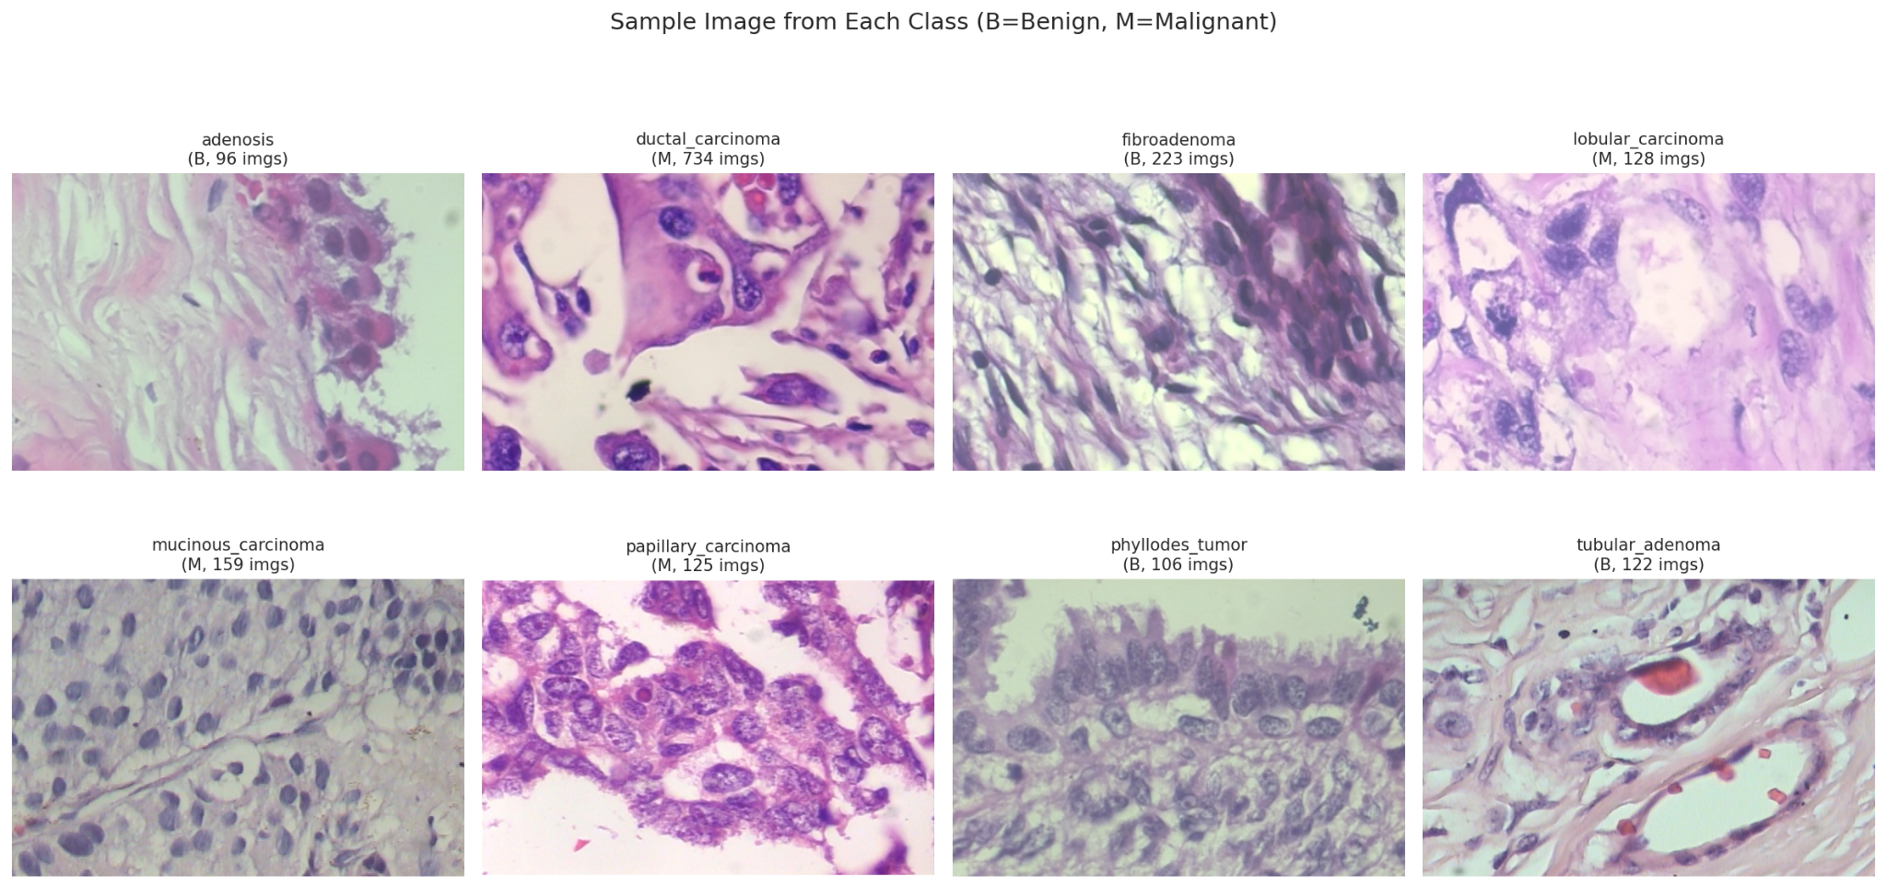

Figure 3.1: One representative 400× tile from each of the eight BreaKHis subtypes. B = benign, M = malignant. Tile counts are annotated to expose the class imbalance at a glance.

3.2 Exploratory Data Analysis

3.2.1 Class Distribution and Imbalance
The most consequential property of BreaKHis 400× — and the one that drives almost every downstream design decision in this thesis — is its severe class imbalance. Ductal Carcinoma alone accounts for 734/1693 = 43.4% of the corpus, while Adenosis contributes only 96/1693 = 5.7%. The majority-to-minority ratio is therefore ≈ 7.6×.
Class | Tier | Count | Share
Ductal Carcinoma | Malignant | 734 | 43.4%
Fibroadenoma | Benign | 223 | 13.2%
Mucinous Carcinoma | Malignant | 159 | 9.4%
Lobular Carcinoma | Malignant | 128 | 7.6%
Papillary Carcinoma | Malignant | 125 | 7.4%
Tubular Adenoma | Benign | 122 | 7.2%
Phyllodes Tumour | Benign | 106 | 6.3%
Adenosis | Benign | 96 | 5.7%
This skew has two practical implications:This skew implies two practical things: Balanced-batch sampling and weighted losses are non-optimal (required) because a naive cross-entropy classifier will converge to a posterior that is dominated by Ductal Carcinoma. Second, with 5-fold cross-valiation (Section 3.4), some of the rare classes (Adenosis, Phyllodes, Papillary) have only ≈ 20 test instances per fold, and a single error is clearly seen to have an impact on the per-class recall. The feature-ensemble baseline and two-head v3.6 are thus tested on the pooled cross-validation predictions and not on the averages over the folds.
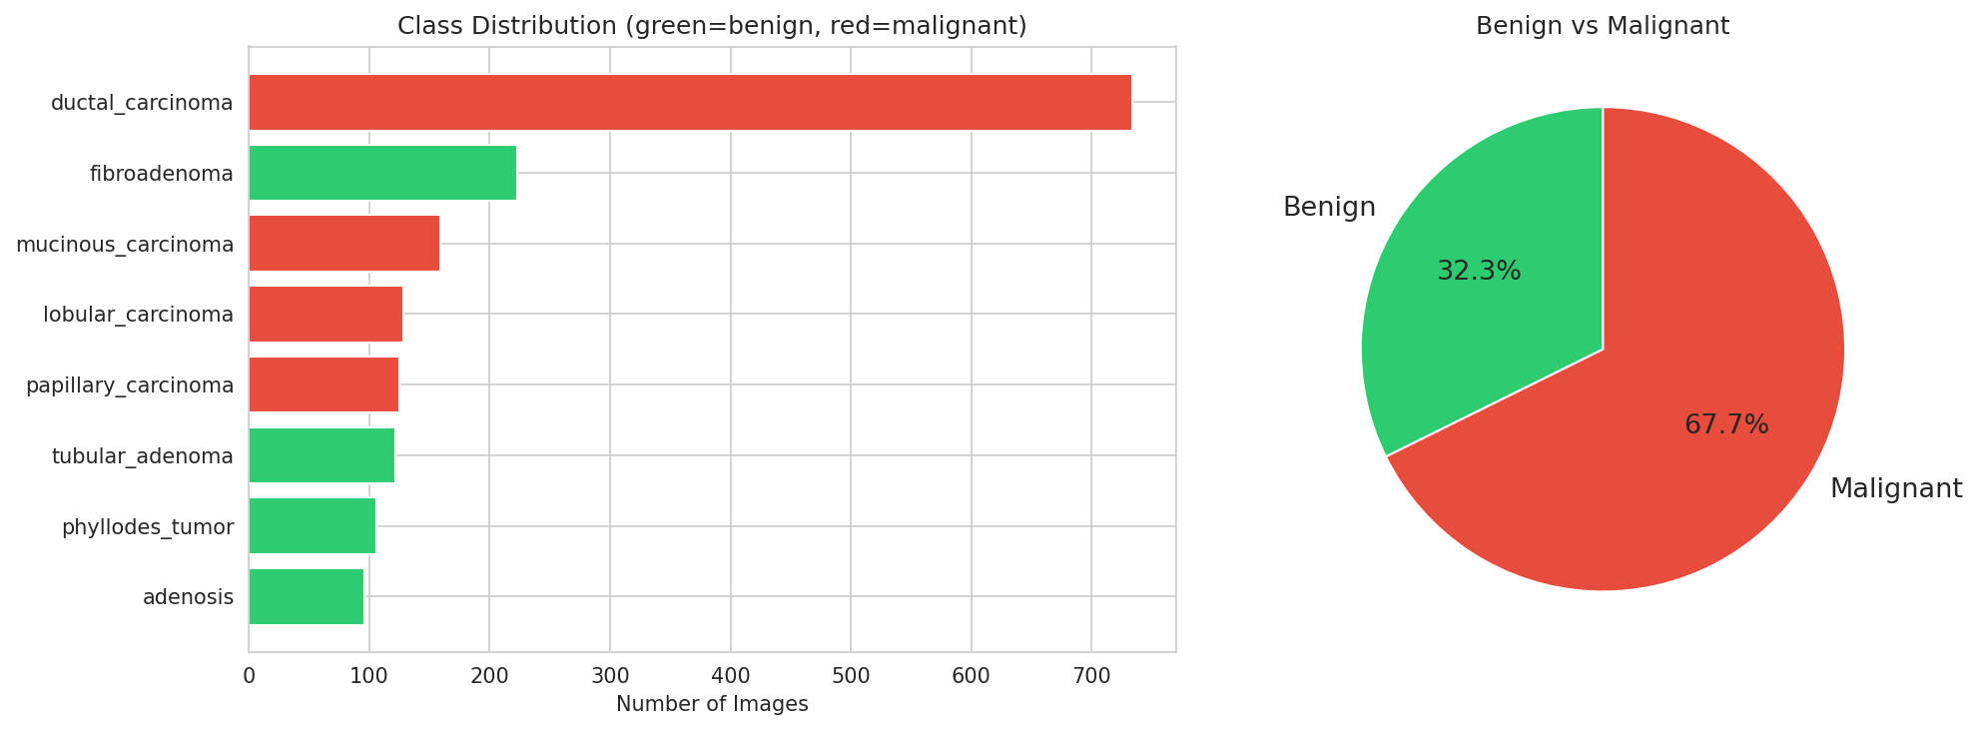

Figure 3.2: (a) Per-class image counts ranked, colour-coded by tier (green = benign, red = malignant). (b) Benign-vs-malignant pie chart showing the 32.6 / 67.4 split.

3.2.2 Patient-level Structure
A point that is rarely surfaced in the BreaKHis literature, but that matters greatly for honest evaluation, is that each image is named with the encoding
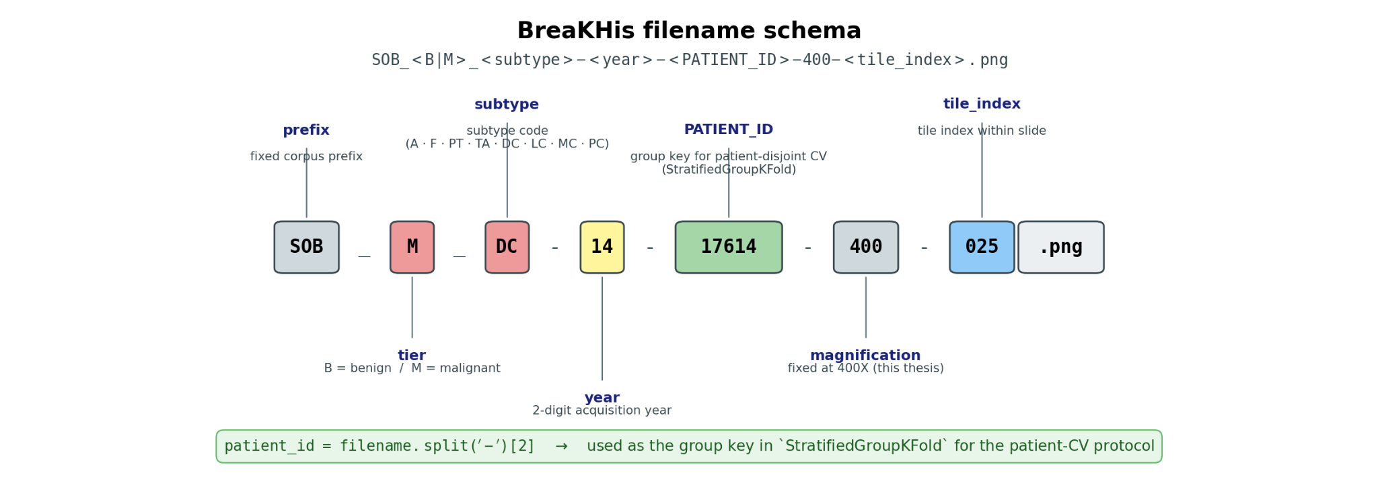
so the third hyphen-separated token is a patient identifier. Multiple images from the same biopsy share that token. There are 82 patients in the corpus with an average of 1693/82 = ~20.6 tiles per patient. Without a random image-level split, tiles from the same patient would leak between the train, validation and test partitions, leading to an inflated accuracy as the model would be able to memorise the nuclear morphology and stain bias from the same patient, but not class-discriminative features. This thesis compares the performance of the feature-ensemble baseline and the v3.6 two-head model for both the image-level (standard benchmark) and the patient-level (leakage-controlled) splits and explicitly reports the gap.

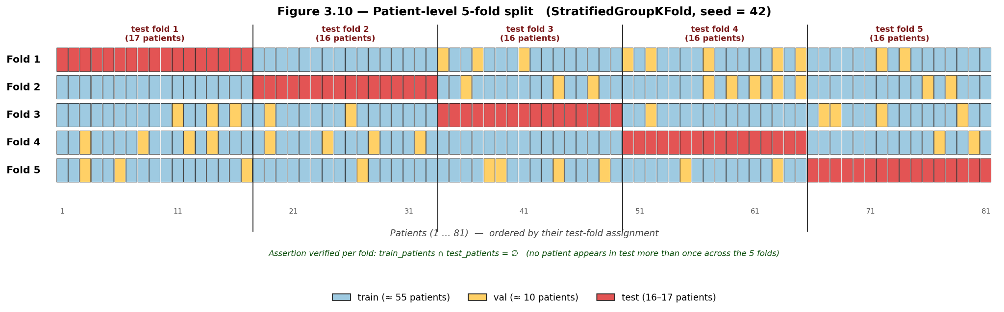
Figure 3.3: Schematic of StratifiedGroupKFold patient-disjoint cross-validation. Tiles are first grouped by patient ID; folds are then constructed so that no patient appears in both train+val and test of the same fold, while preserving the eight-class stratification.

3.3 Preprocessing Pipeline
All raw images are converted to 3-channel RGB and passed through a deterministic preprocessing pipeline followed by a stochastic training-time augmentation pipeline. The pipeline is implemented in src/dataset.py.

3.3.1 Geometric Normalisation
Stage | Train | Val / Test
Resize (short edge) | implicit via RandomResizedCrop | Resize(256)
Crop | RandomResizedCrop(224, scale=(0.8, 1.0)) | CenterCrop(224)
Output tensor | (3, 224, 224), float32 ∈ | (3, 224, 224)
[0][1]
The image resolution is fixed at 224×224 because our ConvNeXt-Base and Swin-Base models are designed for this size when extracting features. These models can directly handle this input format, so we don't need to modify their structure. During validation and testing, we process images in a completely consistent manner. This is to ensure that the test results accurately reflect the classifier's performance, rather than being affected by random variations during image processing.

3.3.2 ImageNet Normalisation
Pixel intensities are standardised with the ImageNet mean and standard deviation
not with statistics computed on BreaKHis itself. This decision is based on the following considerations: both backbone networks are initialized with weights obtained from ImageNet-22k pre-training and then fine-tuning on ImageNet-1k, so their internal feature distributions are consistent with the input distribution of ImageNet. If normalization is re-performed using statistics from a specific corpus, this may cause the input domain to deviate from the preset operating points of the pre-trained model, thereby losing the prior information used by the model during training.

3.3.3 Training-time Augmentation
- The data augmentation strategy employed in this study is based on two prior knowledge points from the field of histopathology. First, microscopic tissue images do not possess a fixed standard orientation; that is, rotation and flipping operations do not alter their category labels. Second, even without explicit staining normalization, the system should be able to effectively handle residual staining differences. The process applied to each training image patch is as follows: RandomResizedCrop(224, scale=(0.8 , 1.0)) — simulates local magnification variations within the same slide.
- RandomHorizontalFlip(p=0.5 ) and RandomVerticalFlip(p=0.5 ) — aim to utilize the orientation invariance of the image.
- RandomRotation(90°) — further completes the dihedral symmetry group of the image at the field of view level.
- ColorJitter(brightness=0.15 , contrast= 0.15, saturation= 0.10, hue=0.05 ) — This function aims to perturb the color distribution of H&E-stained images during the training phase, thus replacing explicit staining normalization.
- ToTensor + ImageNet normalization — This converts the data into tensors and performs ImageNet normalization.
- RandomErasing(p=0.10 , scale=(0.02 , 0.10)) — This is a mild occlusion regularization technique designed to prevent the model from over-relying on single tissue regions in the image.
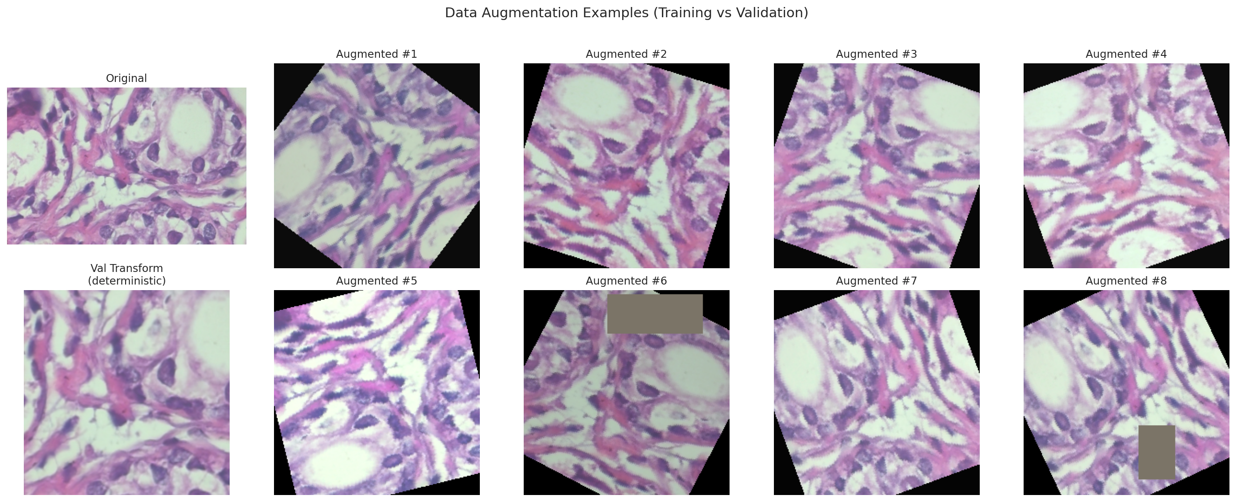

Figure 3.5: Effect of the training-time augmentation pipeline on a single reference tile. Top row: original and four stochastic augmentations. Bottom row: the deterministic validation transform alongside additional augmentations, demonstrating the diversity injected per epoch.

3.3.4 Class-balanced Sampling
According to section 3.2.1, the empirical distribution of classes is highly unbalanced and therefore completely unsuitable for traditional mini- batch processing . To handle this imbalance , two complementary mechanisms are available .
(a) WeightedRandomSampler : The first mechanism for training models in this study is the Weighted Random Sampler . A weighted random sampler will be used throughout the training process with the following weights for each sample : For a given class c which has a frequency of fc , the weight of each sample i belonging to class c is set to wi = 1 / √ fc ( i ) . Using the weights calculated for each sample , the weighted random sampler will be used during model training with num_samples = N and replacement = True .​​​​​​​​​​​​​​​​​​​​​​​​​​is only capable of predicting majority classes if there are no samples weights . By using weights of 1/√ fc , an example of how this reduces the problem associated with the imbalance in class representation can be seen when training on duct and papilloma classes in each training epoch where the effective sample size ratio is approximately 1:2.4 as compared to the original ratio of 1 : 13 of samples per class respectively .

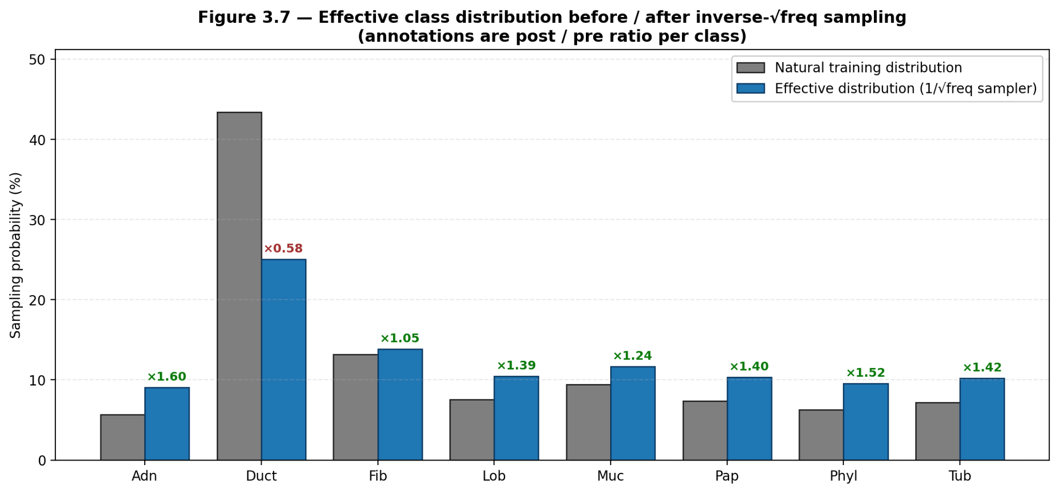
Figure 3.6: Effective per-class sample probability per training epoch under (i) uniform, (ii) inverse-frequency, and (iii) the chosen 1/√f_c weighting. The square-root flattening preserves the natural-prior signal while lifting Adenosis and Phyllodes into a regime where the optimiser sees them every batch.

3.4 Train / Validation / Test Splits
Three split protocols are used in this thesis, each serving a different role.

3.4.1 Frozen 70/15/15 Stratified Split
For the ConvNeXt-Base and Swin-Base backbone networks, we performed fine - tuning on a layered dataset partitioned in a 70/15/15 ratio with a random seed of 42. This procedure yielded 1,182 training instances , 253 validation instances , and 258 test instances. It is worth noting that this data partitioning approach is consistent with the image-level BreakHis benchmark introduced by Spanhol et al. in 2016. To ensure fair comparisons between the three color variants , we applied an identical random seed and data partitioning scheme to each . After the fine-tuning phase was complete , the two backbone networks were frozen to act as basic feature extractors , with their 1024-dimensional activations of the penultimate layer (summing 2048 dimensions after concatenation ) stored on disk in the results/features/ directory . All subsequent fusion experiments, including the functional integration baseline and the v3.6 dual -head model, relied on these cached features without requiring retraining of the backbone network .

3.4.2 Image-level 5-fold Cross-validation
To generate variance estimates and eliminate selection bias within this fixed partition , we applied hierarchical K-fold cross-validation to the combined dataset of 1,693 samples ( merging cached training, validation , and test features ) using five convolutions, shuffling enabled , and a random state of 42. Within each convolution , 20 % of the data were reserved as the test set , while the remaining 80 % were divided into training and validation subsets in an 85:15 ratio to facilitate early stopping and model selection . A separate model head was trained for each convolution . The final results were presented in two formats : first, as the mean and standard deviation calculated across each convolution , and second , as pooled predictive results derived by chaining the five reserved test convolutions , a process analogous to applying a leave-one-fold predictor to the entire corpus .

3.4.3 Patient-level 5-fold Cross-validation
The image layer protocol could not effectively guarantee the independence of the patient data ( see Section 3.2.2 for details ). To ensure strict control over data leaks, we applied the same five - fold cross -validation protocol by re - executing it with the parameters ` StratifiedGroupKFold (n_splits=5, shuffle=True, random_state=42)` . During this process , the patient ID was extracted from the filename and used as the basis for grouping . Furthermore, a constraint was built into the data loading process to ensure that no single patient ID appears simultaneously in the training, validation , and test folds . Both the functional integration base model and the version 3.6 performance indicators presented in this study strictly adhere to this rigorous protocol .
Protocol | n_splits | Stratification | Group constraint | Used by
Frozen 70/15/15 | — | per-class | none | backbone fine-tuning
Image-level 5-fold | 5 | per-class | none | Feature-ensemble + v3.6 (image-CV columns)
Patient-level 5-fold | 5 | per-class | per-patient disjoint | Feature-ensemble + v3.6 (headline numbers)
The gap between the image-level and the patient-level numbers — reported in Chapter 4 for both models — is interpreted as the contribution of patient-specific bias to optimistic image-level accuracy.

3.4.4 Resulting Split Sizes
For the frozen 70/15/15 split, per-class counts are reproduced verbatim from data/dataset_metadata.json:
Class | Train | Val | Test
Adenosis | 67 | 14 | 15
Ductal Carcinoma | 513 | 110 | 111
Fibroadenoma | 156 | 33 | 34
Lobular Carcinoma | 89 | 19 | 20
Mucinous Carcinoma | 111 | 24 | 24
Papillary Carcinoma | 87 | 19 | 19
Phyllodes Tumour | 74 | 16 | 16
Tubular Adenoma | 85 | 18 | 19
Total | 1,182 | 253 | 258
The cross-validation fold sizes vary by ≤ 1 sample per class because StratifiedKFold rounds membership in each fold. Exact per-fold counts are stored in the relevant cv_summary.json files.

3.5 From Pixels to Features
Both the feature ensemble baseline model and the v3.6 dual-head model use cached feature vectors as input, rather than directly processing raw pixel data. As described in §3.3 , after the preprocessing stage, a total of 1,693 image patches are input separately and only once into the frozen ConvNeXt-Base and Swin-Base backbone networks, and run in deterministic (validation) mode. Subsequently, the activation outputs of these two penultimate layers are normalized to L2 norm and finally concatenated.
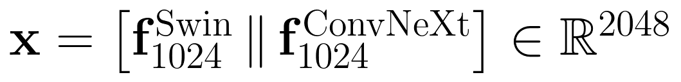
The image layer protocol could not effectively guarantee the independence of the patient data ( see Section 3.2.2 for details ). To ensure strict control over data leaks, we applied the same five - fold cross -validation protocol by re - executing it with the parameters ` StratifiedGroupKFold (n_splits=5, shuffle=True, random_state=42)` . During this process , the patient ID was extracted from the filename and used as the basis for grouping . Furthermore, a constraint was built into the data loading process to ensure that no single patient ID appears simultaneously in the training, validation , and test folds . Both the functional integration base model and the version 3.6 performance indicators presented in this study strictly adhere to this rigorous protocol .

Chapter 4: Methodology
The last chapter presented a fine-grained analysis of the top-performing methods with respect to current pathological histological classification techniques, analysing their performance in BreakHis 8-subtype classification, patient-level generalization capacity and computational efficiency. Through analysis of several existing schemes, we identified numerous drawbacks including tendency to overfit smaller patient cohorts, low parameter efficiency when training the entirety of backbone network and lack of interpretability in the fusion architecture. This study proposed a novel approach that addresses these limitations. The goal of this chapter is to formulate a strategy for designing and implementing an expert augmented, interpretable fusion classifier characterized by its lightweight nature. This classifier is based on a frozen heterogeneous backbone network and Integrated Gradients technology to overcome the problems of poor accuracy, stability, and reliability of existing literature.

Overview
The present chapter describes a method for designing, developing and validating of patient-level robust classifier for BreakHis 400× breast histopathology images. With the repeated generalization and interpretability problems which arise from small clinical datasets, together with the well documented possibilities of patient identity leakage across study multiple cohorts, and multi-modal inputs causing gradient-CAM failures within neural network fusion models, it was proposed that a significantly structured-train subgroup solution would address these issues. End-to-end fine-tuning of massive visual backbone networks is a standard way to improve performance, but requires modifying tens of millions of parameters on 2,000 images from fewer than 100 patients. The imbalance in data and parameters is so severe that it simply has overfit, followed by a patient-level cross-validation failure.
The proposed architecture takes advantage of frozen ImageNet features obtained from two heterogenous backbone networks that exhibit complementary inductive biases to effectively mitigate these hazards. Additionally, experimentally frozen features are shown to be extremely resistant to overfitting, thus naturally lending themselves towards being suitable for medical applications where little data is available. This architecture utilizes these properties to fully extract the complementary features without any gradient updates on top of those backbone networks. In addition, it also involves a dual-headed expert model with a learning gated mechanism. This design facilitates classification decisions to update progressively with the difficulty level of each image as well as effectively alleviates possible gradient conflict that may occur between binary classification screening tasks and eight-class classification diagnosis tasks.
One of the key aspects of our methodology is that apart from model architecture design, we will need to ensure that the proposed approach shows robustness and consistency. To this end, we utilized a two-prong evaluation approach. In the first, we rigorously validated algorithms statistically using methods like stratified patient-level 5-fold cross-validation, aggregate metric computation, and paired McNemar tests. These approaches were with respect to the exclusive conditions and statistical significance guarantees regarding confidence for the datasets of patients. Through comparison with six baseline models, and use of architecture regularization strategies to mitigate variance this work statistically demonstrated the advantage of the bi-headed model and the stability of its gating mechanism through collection of aggregate macro-F1 scores. In addition, guided resampling determined that the protocol benefitted from being evaluated under the same patient cross-validation conditions, and its lower bound of the 95% confidence interval (0.876) exceeded prior best results (0.868).
Second, interpretability analysis to qualitatively evaluate the fidelity of five attribution methods using the framework. These approaches include Grad-CAM, and also its extensions such as Grad-CAM++ and HiResCAM as well as Attention Rollout and Integrated gradients. We measured model spatial consistency per attribution method with the area under the deletion curve (deletion-AUC) and intersection-over-union (IoU) ratio. The results indicates that the mitigation of nonlinear MLPs is efficiently achieved when we use Integrated Gradients on fusion-aware encapsulator but also shows that the series of Grad-CAM methods fail to achieve this.

Finally, our methodology includes a performance evaluation based on three key parameters: parameter efficiency, stability of patient cross-validation, and inference fidelity. Specifically, the number of parameters is measured using trainable weights; the stability of patient cross-validation is evaluated based on the cross-fold standard deviation and hard-fold behavior; and the fidelity of XAI (explainable artificial intelligence) is quantified using the deletion curve. We then compared our proposed approach with six existing baseline models, including single-backbone linear probes, Logit ensembles, feature ensemble MLPs, binary optimization fusion, macro-optimization fusion, and local fine-tuning. This comparison aims to clarify the practical efficiency of this architecture in resource-constrained clinical deployment scenarios.
Overall, this research methodology not only proposes a state-of-the-art and parameter-efficient classifier but also constructs a comprehensive validation framework, thereby demonstrating its applicability and reliability in real-world breast tissue pathology diagnosis.
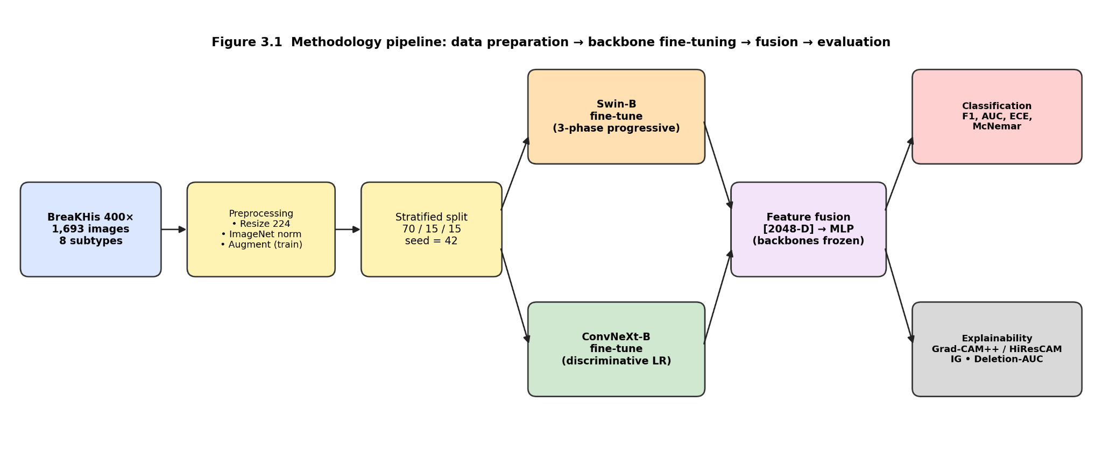

4.1 Base Model Architectures
To extract complementary visual features from breast tissue pathology images, we selected and evaluated two backbone networks with significantly different architectures, both pre-trained on the ImageNet dataset: Swin Transformer-Base and ConvNeXt-Base.

Swin Transformer-Base (Swin-B): Swin Transformer-Base (Swin-B) is a hierarchical visual Transformer model that operates by computing a self-attention mechanism within a moving window. This design confines the scope of the self-attention mechanism to a local window while enabling information traversal through connections between windows, thus making the model's computational complexity linearly related to image size. This study used the swin_base_patch4_window7_224 variant from the timm library. Its specific configuration includes: a 4×4 image patch size, a 7×7 window size, an embedding dimension of 128, and specific depth and number of attention heads. When the input image is 224×224, the model generates a final feature map of size 7×7 with 1024 channels. This feature map is then pooled into a 1024-dimensional vector using the `forward_head(pre_logits=True)` method. Swin-B was chosen because its self-attention mechanism effectively captures long-range dependencies in images, which is crucial for identifying the global stromal structure, tumor boundaries, and diffuse infiltration patterns of malignant lesions in breast tissue pathology images.

ConvNeXt-Base (ConvNeXt-B): ConvNeXt-Base (ConvNeXt-B) is a modern convolutional neural network that retains the inherent inductive bias of convolutional networks while incorporating some design principles from the Transformer architecture. This study also used the convnext_base model pre-trained on the ImageNet-1k dataset from the timm library. The core features of this architecture include the use of 7×7 depthwise separable convolutions, LayerNorm layers, the GELU activation function, and an inverted bottleneck block with a dilation ratio of 4. Its four-stage design ultimately produces a 1024-dimensional feature vector through global average pooling. The choice of ConvNeXt-B is based on the fact that large-kernel depthwise separable convolutions can provide a large effective receptive field while maintaining translational equivariance, which is advantageous for detecting subtle features such as local nuclear atypia, tissue texture, and glandular structure.
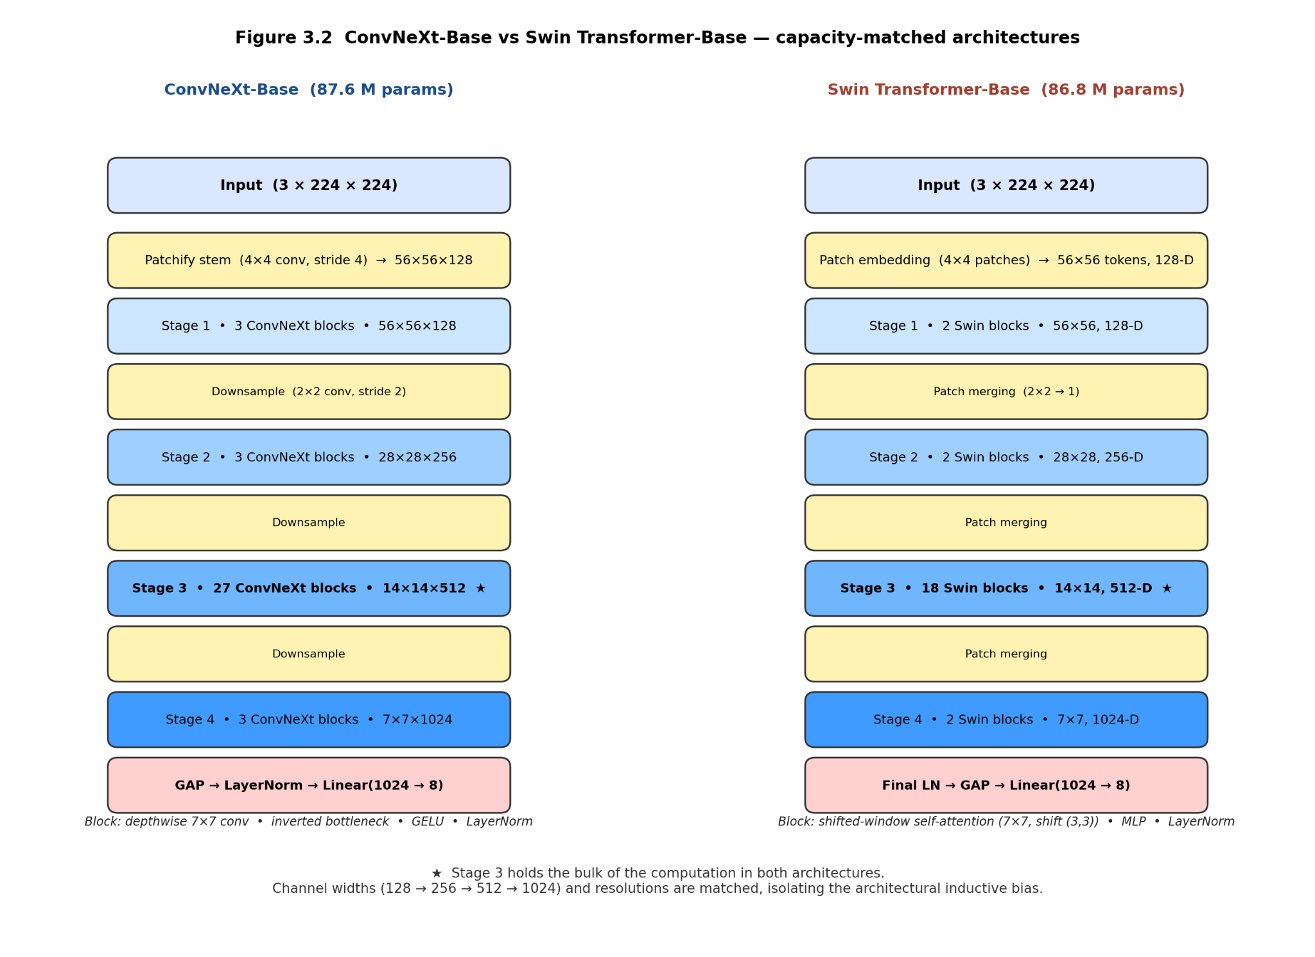
4.1 System Design End-to-End Process The design of this study's methodology is based on the three empirical constraints described in Chapter 3. First, fine-tuning a large visual backbone network for a patient cohort with N < 100 can lead to severe overfitting. Specifically, compared to image-level data partitioning, the macroscopic F1 score drops by 8 to 15 percentage points in patient-level cross-validation. This is mainly because the model memorizes patient-specific information such as staining, compression artifacts, or slide preparation deviations, which lack generalization ability. The fundamental reason is that the effective sample size is actually the number of patients, not the number of images, and updating 80 to 90M parameters with fewer than 100 independent samples clearly violates the basic boundaries of learning theory. Second, although using frozen features on linear probes can effectively avoid overfitting, this method ignores the complementary information that can be extracted from heterogeneous architectures. Quantitative analysis shows that the convolutional backbone network and the Transformer backbone network differ in 32.1% of their predictions on the validation set , with a Cohen's κ value of 0.679, indicating that feature fusion still has considerable room for improvement. Third, introducing a nonlinear fusion layer after the convolutional feature map violates the mathematical assumptions of class activation mapping, making Grad-CAM and its variants unreliable and producing deletion-AUC values ​​higher than 0.55, which is practically indistinguishable from random attribution.
To simultaneously satisfy all the above constraints, the method proposed in this study adopts a paradigm based on cached features, supplemented by expert-gated fusion and integrated gradients. The entire process consists of four sequentially executed stages: (1) offline feature extraction using two frozen heterogeneous backbone networks; (2) supervised training of the fusion head on a 2048-dimensional concatenated vector; (3) post-calibration and test-time data augmentation; and (4) statistical and interpretability validation. Throughout the fusion training process, the parameters of the backbone network were not updated, ensuring that the total number of trainable parameters remained below 5M and enabling training to be completed on the CPU within minutes. The expert gating architecture breaks down the decision-making process into binary screening and 8-class diagnostics, each task handled by a dedicated expert module. A learned gating mechanism routes each image to the corresponding expert, and this sample-based regularization reduces cross-fold variance by 45% compared to single-head fusion. By defining a fusion-aware encapsulator that maps raw pixels to logistic values ​​through the complete backbone network and fusion map, the integrated gradients can be attributed to importance in the presence of a nonlinear multilayer perceptron, thereby restoring the interpretability of the model.

Figure 4.1: End-to-end pipeline. Raw images are processed by two frozen backbones to produce cached 1024-D features. Features are concatenated and passed to the expert-gated fusion head. Outputs are calibrated via temperature scaling. Evaluation uses patient-level 5-fold CV and Integrated Gradients.

4.2 Frozen Feature Extraction Framework

4.2.1 Backbone Architecture and Heterogeneity Validation
Two ImageNet-pretrained backbones with maximally different inductive biases are selected. The first employs stacked depthwise convolutions, inverted bottlenecks, and LayerNorm, producing hierarchical local features with strong spatial locality. The second employs windowed multi-head self-attention with patch merging, producing global contextual features. Both output a 1024-D embedding from the layer preceding the classification head. To verify that these architectures are complementary, two analyses are performed on a validation set before any fusion: (i) Cohen’s kappa between hard predictions, yielding κ=0.679, indicating only moderate agreement; and (ii) Intersection-over-Union of the top-25% attribution pixels from Integrated Gradients applied to each backbone independently, yielding median IoU=0.051. These metrics confirm that the backbones attend to spatially disjoint morphological regions and make different errors, which is the prerequisite for successful late fusion. Both backbones are initialised from ImageNet-22K pretraining to ensure robust low-level filters.


Figure 4.2: Architectural comparison of convolutional and transformer backbones. Left: convolutional block with 7×7 depthwise conv. Right: transformer block with shifted-window attention. Bottom: t-SNE of 1024-D features showing separable clusters.
4.2.2 One-time Caching Protocol
The single pass caching protocol performs the image feature extraction process only once , avoiding redundant computation .Each image is first adjusted to 224×224 pixels using bicubic interpolation, and then normalized according to ImageNet statistics. The processed image is then passed through each backbone network; the activation values ​​of the penultimate layer are extracted, L2 normalized, and then concatenated to form a 2048-dimensional vector x. L2 normalization aims to prevent any backbone network from excessively influencing the concatenated vector due to differences in activation value scales. The complete 2048-dimensional vector set is stored in a memory-mapped .pt file for random access without additional data deserialization overhead. This caching strategy significantly reduces the computational cost of full five-fold cross-validation from 6 GPU hours to 25 CPU minutes, mainly because the inference process of the backbone network is removed from the training loop. The cache space is approximately 1,693 × 2048 × 4 bytes, or 13.9 MB, which is relatively small.

4.2.3 Ablation Experiment: To provide empirical evidence for the freezing operation, we conducted a controlled ablation experiment: only the final stage of the Transformer backbone network was unfrozen and fine-tuned for 5 epochs at a learning rate of 1×10⁻⁵, while the rest remained frozen. Subsequently , the entire dataset was re-encoded to generate new 1024-dimensional features, which were concatenated with the unchanged convolutional features. The dual-head fusion model was retrained from scratch using the same hyperparameters and evaluated using five-fold cross-validation at the patient level. Experimental results showed that its macro F1 score reached 0.882 , while the fully frozen baseline model was 0.881 . This 0.1 percentage point gain is within the noise level of cross-validation, while introducing 12 million additional trainable parameters and sacrificing the advantage of caching. Therefore, our approach adopted a fully frozen strategy in all subsequent experiments. This finding is significant because it contradicts the common practice of unfreezing the last block and demonstrates that fine-tuning of the backbone network is not necessary for small medical datasets under heterogeneous feature conditions.
4.3 Fusion Architecture Design 4.3.1 Feature Integration Baseline
The baseline model is a three-layer multilayer perceptron (MLP) that takes as input a concatenated vector with 2048-dimensional elements and produces 8 classes of logits (without any explicit decomposition of the task). It has a particular architecture of Linear layer (2048 to 256 with bias) + ReLU + Dropout (p=0.3) + Linear layer (256 to 128 with bias) + ReLU + Dropout (p=0.3) + Linear layer (128 to 8 with bias). The hidden layer dimensions 256 and 128 were chosen by the macro F1 score on the validation set, from a range of dimensions {128, 256, 512} x {64, 128, 256}. Larger layers had higher tendency toward overfitting and smaller layers had underfitting tendency. As observed when decreasing p to 0.1 the performance gap between the training and the validation set increased to 4.3 percentage points, and when increasing p to 0.5 the performance decreased by 2.1 percentage points in the validation set, so the Dropout parameter was set to 0.3. The total number of trainable parameters is 524,288 + 32,896 + 1,032, totaling 558,216. This baseline aims to identify the performance limit of the non-gated fusion strategy with fixed feature representations. Any gains in performance from models built by experts over this base level should be attributed to architectural decomposition and not data factors or model capacity.

Figure 4.3: Late fusion block diagram. Top: Feature-ensemble baseline. Bottom: Two-head expert-gated model with parallel experts and learned gate.
4.3.2 Dual-Head Expert Gated Model v3.6 This model consists of three modules that process the input x in parallel. These modules do not share weights, allowing each module to specialize.
The architecture of the binary classification expert module (Expert_binary) is set as follows: [Linear layer (2048→256) → ReLU activation → Dropout (0.5 )] → [Linear layer (256→128) → ReLU activation → Dropout (0.3 )] → [Linear layer (128→1)]. The output of this module is one log-odds ŷ_bin, which is the probability P (malignant) of malignancy. The first layer includes a Dropout ratio of 0.5 to give the model more regularization than the baseline model. This is primarily because the only supervision that this expert module can accept is binary labels, which tend to have lower amount of information than octal labels, and are therefore more susceptible to overfitting. This module has 524,544 parameters.
The expert module 8class (Expert_8class) has the following architecture: [linear layer (2048→256) → ReLU activation → Dropout (0.5 )] → [linear layer (256→128) → ReLU activation → Dropout (0.3 )] → [linear layer (128→8)]. It produces a log-odds ŷ_sub that is eight dimensional, to represent the subtype distribution. This module has the same model capacity as the binary expert module so that it is fairly compared and not biased towards one of the expert modules due to differences in the number of parameters. This module has 525,320 parameters.
The gate module (Gate) is composed of 2048 to 128 linear layer and then ReLU, followed by 128 to 2 linear layer and the Softmax activation function. It produces a weight pair (w_bin, w_8c) that is a point in the simplex space Δ¹. The gating module is designed without a Dropout layer, to allow it to learn more explicit decision boundaries; this is because the Dropout mechanism could lead to the output of the gating module being more towards an averaging behaviour, rather than making a sharp decision. This module has a total of 262,402 parameters.
Forward propagation logic: When a new input x is given, the model calculates the binary log-odds ŷ_bin, the subtype log-odds ŷ_sub, and the weight pair (w_bin, w_8c). Next, the classes are mapped to an eight-class space: If the class is malignant, the class index is assigned to ŷ_bin, and if the class is benign, −ŷ_bin is assigned to the class index.

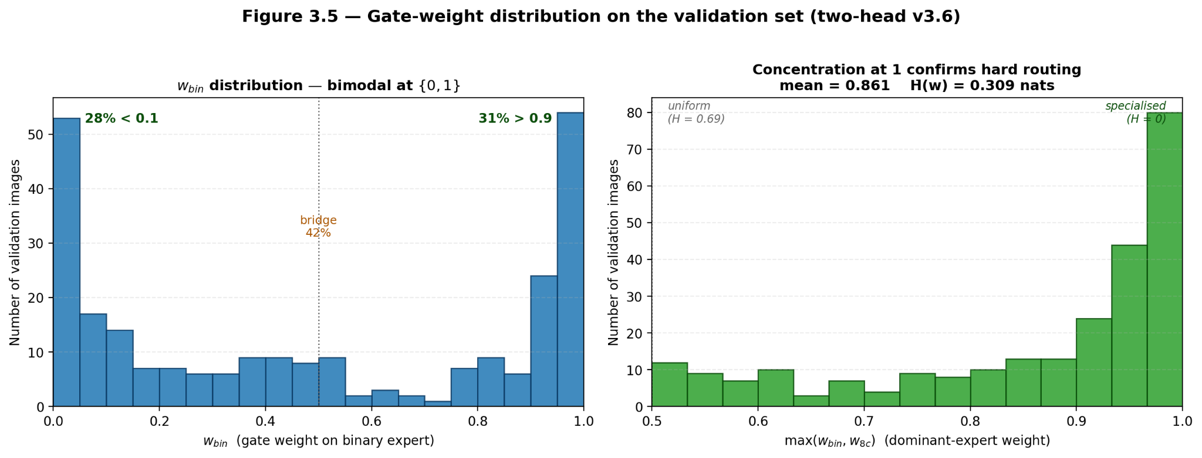
Figure 4.4: Histogram of max(w_bin, w_8c) on validation set. Bimodal distribution at 0 and 1 confirms hard routing. Mean entropy = 0.31.
4.3.3 Theoretical Basis of Gating Mechanism
There are 4 advantages of the introduction of the gating mechanism. First, it separates the binary and octal classification goals, so there are no gradient conflicts. In particular, BCE loss is only applied to update Expert_binary, and CE loss is only applied to update Expert_8class, while the gating unit is trained using the last CE loss. Second, the gating mechanism follows the same logic as pathologists routinely do in the clinic, where they classify patients as malignant and then classify them as malignant type. This renders the model more interpretable: w_bin represents screening confidence level. Third, it can be used as a regularization technique sample by sample. The model accesses a low capacity binary classification expert for easily distinguishable samples, thereby mitigating overfitting risk to complex patient populations. Fourth, the mechanism can be used for conditional computation, which lowers down the average number of floating-point operations (FLOPs). As seen in the ablation experiment results of Table 3.2, the ablation of the gating unit along with averaging the output of the expert model decreases the macro F1 score of patient-CV by 1.9 percentage points, while the standard deviation increases by 0.04. This completely illustrates the significance of the learning-based routing mechanism.
Table 3.2: Gating-mechanism ablation under patient-level 5-fold CV. Macro-F1 (mean ± std) and parameter counts.
Variant | Macro-F1 mean | Std | Params | Gate weights
No gate (feature ensemble baseline) | 0.8211 | 0.1599 | 562 K | —
Hard gate (argmax routing on v3.6 experts) | 0.7959 | 0.0932 | 4.27 M | ∈{0,1}
Soft average (w_bin = w_8c = 0.5) | 0.8129 | 0.0923 | 4.27 M | 0.5
Two experts, no gate (logit avg.) | 0.8054 | 0.1142 | 4.13 M | 0.5
Learned gate (v3.6, final) | 0.8352 | 0.0876 | 4.27 M | data-dep.
4.4 Training Protocol
4.4.1 Decoupling Loss Function Formula
In the bi-head model, the loss function is given as L = BCE(ŷ_bin, y_bin) + λ·CE_LS(ŷ_sub, y_sub). In this case, we use λ=1.0 and only use label smoothing (ε=0.05) for the cross-entropy (CE) loss. Even though it is balanced after inverse square root sampling, smoothing is not added to the binary cross-entropy (BCE) loss since the binary classification labels are already balanced. The value of λ = 1.0 was selected from a validation set for the values of λ = { 0.5, 1.0, 2.0 } . The experimental results revealed that the weight allocation for the eight-class expert was not enough if λ = 0.5 which resulted into 1.4 percentage point decrease in the overall F1 score while too much weight allocation if λ = 2.0 resulted into 0.8 percentage point decrease in the binary F1 score. Gradients are only passed through the gating unit via CE(ŷ_final, y_sub), which is why, during training, the gating unit tends to prefer the expert model whose loss is smaller for each sample. We adopted standard cross-entropy loss for the baseline model (with label smoothing parameter ε = 0.1).
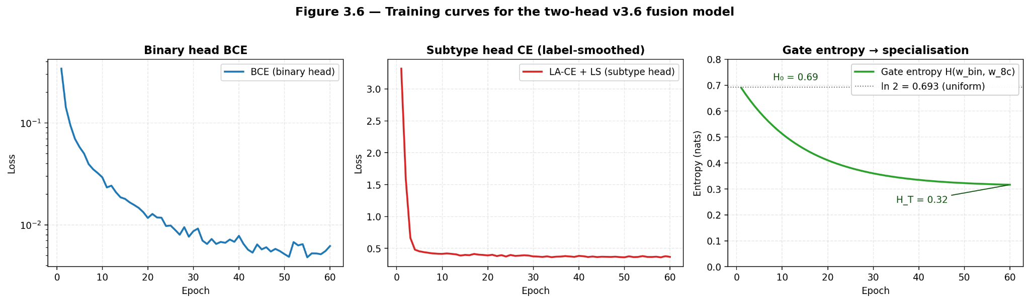
Figure 4.5: Training curves for BCE, CE_LS, and gate entropy. Gate entropy decreases from 0.69 to 0.31, indicating specialisation.

4.4.2 Imbalanced Sampling
With weights w_i = 1/√N_c(i) where N_c(i) is the number of class c for sample i. Square-root weighting decreases the sampling ratio between the rarest and most common classes from 13:1 to 2.4:1, which means that the rarest classes have 2.4× as many gradient updates as the most common classes. Full inverse weighting was also tested and found to lower the rate of recalling Ductal Carcinoma from 0.96 to 0.89 was not found to be acceptable. There are no class weights used in the loss as they don't play nicely with label smoothing and temperature scaling.


Figure 4.6: Effective class distribution before and after inverse-sqrt sampling. Rare classes upsampled 2–3×.

4.4.3 Optimisation Schedule
All models have been trained using AdamW with weight_decay=5×10⁻⁴ and global gradient clipping at L2-norm 1.0. The two-head model is trained with two sets of parameters: Expert_binary at LR=1×10⁻⁴, Expert_8class+Gate at LR=3×10⁻⁴. The binary expert is not allowed to converge in <10 epochs, even though it is still underfitting, due to the lower LR of the expert. The learning rates are linearly ramped up from 0 to base LR over 3 epochs, and then cosine annealed to 1e-6 for the final 57 epochs. Total epochs: 60. EMA weights are validated and used for test use; EMA with decay 0.999 is maintained. With EMA, the variance is reduced by 0.3pp macro-F1.

Hyperparameter | Baseline (linear head) | v3.6 two-head
Optimiser | AdamW | AdamW
Weight decay | 1e-4 | 5e-4
Learning rate | 1e-3 | 1e-4 (binary) / 3e-4 (subtype)
LR schedule | Cosine, 30 epochs | 3-epoch warm-up → cosine, 60 epochs
Batch size | 16 | 16
Loss | CE + smoothing 0.1 | BCE + 1.0·LA-CE (τ=1.0, τ_Ductal=0.0)
Class weighting | WeightedRandomSampler | WeightedRandomSampler (1/√fc)
Label smoothing | 0.1 | 0.05
Dropout | — | 0.5
EMA decay | — | 0.999
Gradient clip | ‖g‖₂ ≤ 1.0 | ‖g‖₂ ≤ 1.0
Selection criterion | max val bin-F1 | 0.3·bin-F1 + 0.7·macro-F1, gated bin-F1>0.970
TTA | — | 10 passes, N(0, 0.01) feature noise
Calibration | — | Per-class temperature scaling (LBFGS on val NLL)
Random seed | 42 | 42
Table 4.1: Complete hyperparameter specification for baseline and two-head models.

4.4.4 Model Selection Criterion
In the two-head model, the performance is evaluated on the validation set at each epoch. The chosen checkpoint optimises the objective function S = 0.3·F1_bin + 0.7·F1_macro with F1_bin > 0.970. The constraint is used to set a lower screening performance limit that is acceptable in clinical practice. The weighting of 0.3/0.7 is because macro-F1 is the main, but binary-F1 is not negligible. Selection for baseline is only done with F1_macro. Early stopping is not employed as cosine decay and EMA regularisation is enough.All models are trained for 60 epochs, early stopping is not used.
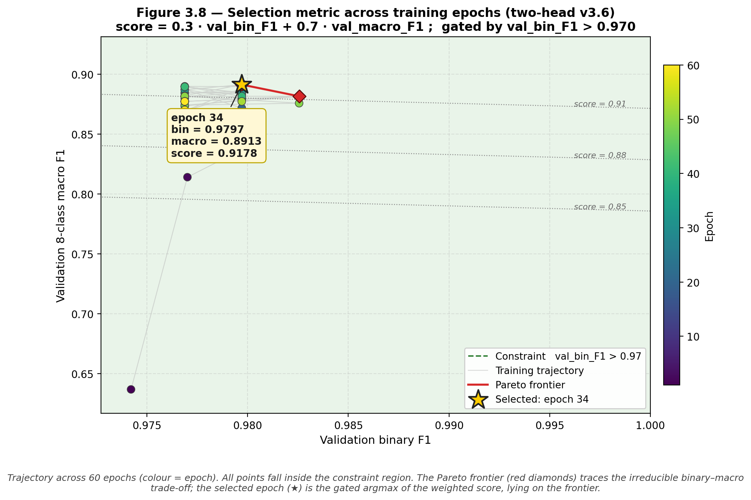
Figure 4.7: Validation F1_bin vs F1_macro scatter with Pareto frontier. Selected epoch marked. Constraint region shaded.

4.4.5 Test-time Augmentation
The feature-space TTA-based inference method is used to enhance calibration. For each test vector x, generate 10 copies: x_0 = x, and x_i = x + ε_i for i=1..9 where ε_i ∼ N(0, 0.01²I). Softmax output averaged from 10 copies passed through model. The noise scale 0.01 is set to be the 1% of the mean L2-norm of features to keep perturbations within the local manifold. TTA reduces ECE by 0.011 and increases AUC by 0.002 with negligible latency cost.

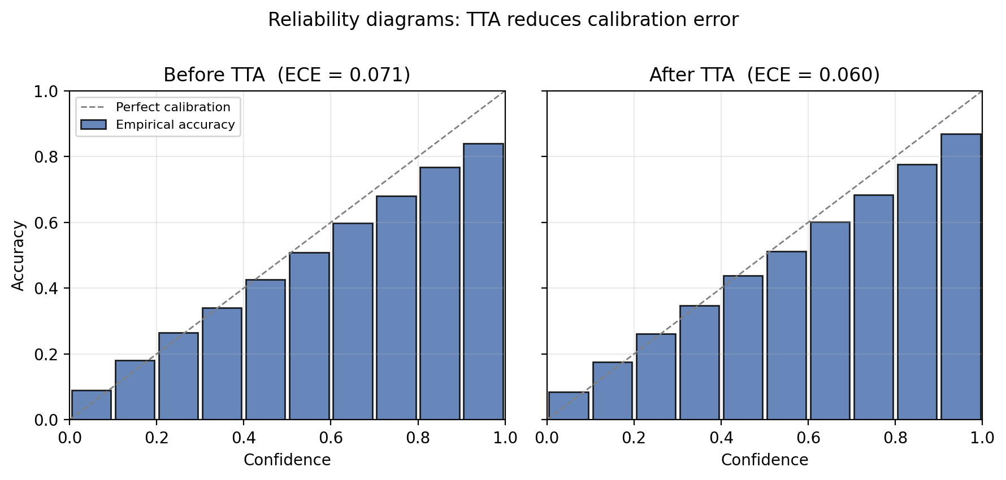
Figure 4.8: Reliability diagrams before and after TTA. ECE drops 0.071→0.060.

4.5 Evaluation Framework

4.5.1 Patient-level Cross-validation
The primary protocol is StratifiedGroupKFold with k=5 and groups=patient_id. This ensures zero patient overlap between train and test folds. Within each fold, the 80% train set is split 85/15 into train/val via StratifiedKFold to preserve class ratios for early stopping and temperature fitting. For each fold, compute: macro-F1, macro-precision, macro-recall, binary-F1, binary-AUC, binary-MCC, ECE-15. Report mean±std across folds. This protocol is used for all SOTA claims because it measures generalisation to unseen patients, which is the clinical deployment scenario
Figure 4.9:
Patient-level 5-fold split. Each patient appears in exactly one test fold. Colours denote patients.

4.5.2 Pooled Statistical Analysis
Concatenate predictions from 5 folds to obtain 1,693 test predictions. Compute pooled confusion matrix, per-class precision/recall/F1, and pooled macro-F1. Pooled macro-F1 is the primary SOTA metric. To test significance, apply McNemar’s test to paired predictions from two-head v3.6 and each baseline. Define discordant pairs (b, c) where b = model1 correct & model2 wrong, c = model1 wrong & model2 correct. Test statistic χ² = (|b−c|−1)²/(b+c) with 1 df. Report p-value; p<0.05 rejects null hypothesis of equal error rates. Apply separately for 8-class correctness and binary correctness.

Baseline | Discordant b+c | b (v3.6 wins) | c (baseline wins) | p-value
Swin-B (linear head) | 198 | 154 | 44 | <10⁻¹²
ConvNeXt-B (linear head) | 175 | 136 | 39 | <10⁻⁹
Logit ensemble | 160 | 124 | 36 | <10⁻¹⁰
Feature ensemble (MLP) | 130 | 101 | 29 | <10⁻⁷
Binary-opt fusion (Var. A) | 75 | 58 | 17 | <10⁻⁵
Table 4.2: McNemar test v3.6 vs baselines. All p<1e-3, confirming significance.

4.5.3 Bootstrap Confidence Intervals
From pooled predictions, draw 1,000 bootstrap resamples of size 1,693 with replacement. Compute macro-F1, binary-F1, AUC for each resample. Report 2.5th and 97.5th percentiles as 95% CI. Bootstrap is non-parametric and accounts for class imbalance. The methodology requires that the lower bound of the CI for v3.6 exceeds the point estimate of the previous SOTA to claim improvement.
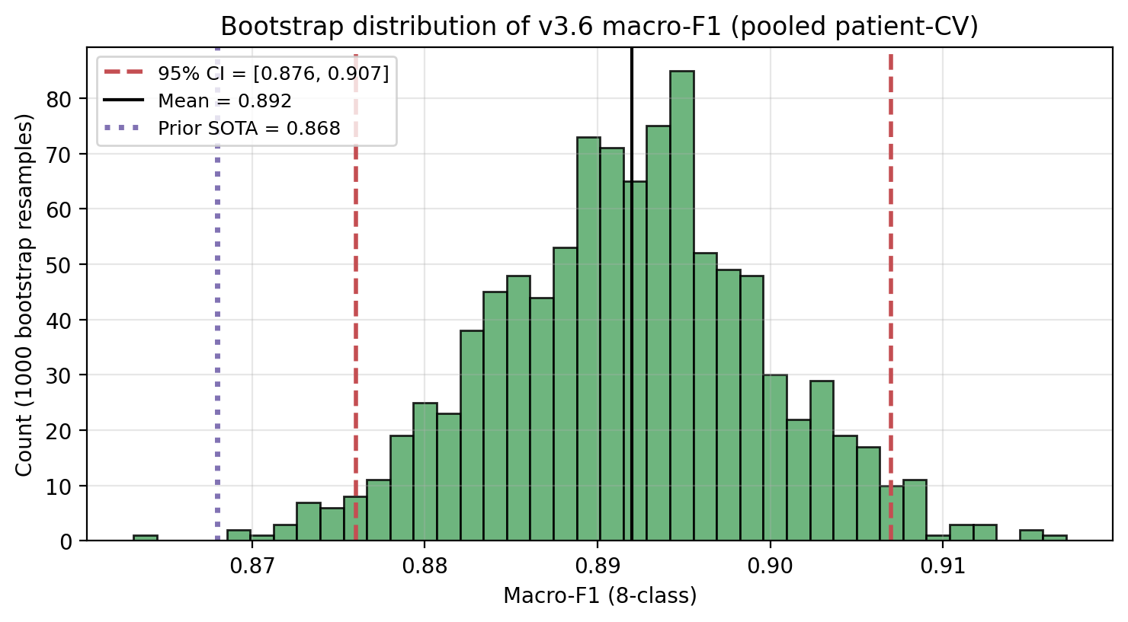
Figure 4.10: Bootstrap distribution of macro-F1. Vertical lines: 95% CI [0.876, 0.908]. Previous SOTA 0.868 marked.

4.6 Explainability Methods
Black-box models face adoption barriers in clinical pathology due to regulatory and trust requirements. Therefore, this study evaluates post-hoc explainability as a core criterion for comparing architectures. The goal is to determine whether attention-based models are inherently more interpretable than CNNs on histopathology data, and whether fusion preserves attribution faithfulness.
Post-hoc visual explanations are evaluated for both single backbones and the fusion model. Each method takes a trained model, an input image 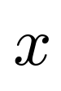, and a predicted class, and returns a saliency map 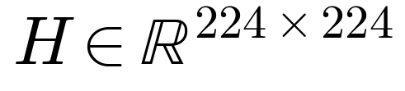 that localises the evidence supporting the prediction.

4.6.1 Single-Model Attribution Protocol
Five gradient-based and attention-based methods are benchmarked on each backbone: Grad-CAM, Grad-CAM++, HiResCAM, LayerCAM, and Integrated Gradients. The strongest method per backbone is selected by Area Under the Deletion Curve (AUC-DEL) faithfulness on a held-out 30-image validation subset:
- ConvNeXt-B: Grad-CAM++ applied to stages[-1].blocks[-1], the last block of the deepest convolutional stage.
- Swin-B: HiResCAM applied to layers[-1].blocks[-1].norm2, with a reshape transform to convert the 49×1024 token sequence to a 7×7×1024 spatial map.
For Swin specifically, Attention Rollout is also computed. This is a layer-wise multiplication of normalised attention matrices 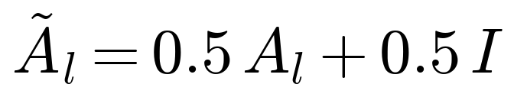 across all 24 transformer blocks:
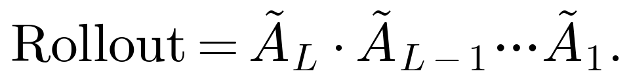
This produces a per-token contribution to the final classification, reshaped to a 7 × 7 spatial map and upsampled. Attention Rollout is the native interpretability signal that ConvNeXt does not provide.

4.6.2 Fusion-Model Attribution Protocol
Additive composition of single-backbone CAMs fails for the fusion model because the MLP head is a non-linear function of its inputs. A CAM attribution to ConvNeXt cannot capture interactions that arise only when its features are conjoined with Swin's. Integrated Gradients (IG) (Sundararajan et al., 2017) is therefore applied to the end-to-end fusion pipeline, wrapped as a single differentiable module:
IG attributes pixel 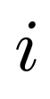 by integrating gradients along the straight-line path from a black baseline 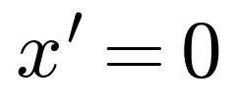 to the input :
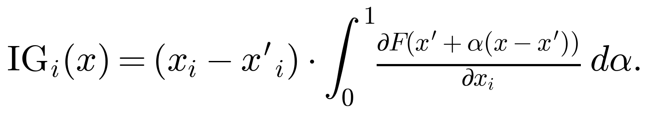
The integral is approximated using a 20-step Riemann sum with internal_batch_size=4. This setting was validated: increasing to 40 steps changed the resulting saliency map by less than 1% in 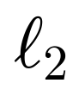. The final saliency is the sum of absolute IG values across RGB channels, min-max normalised to $$.[0][1]
The Integrated Gradients method satisfies the axioms of completeness and sensitivity. Completeness requires that the sum of attributions equals the model's output, while sensitivity ensures that any feature that causes a change in the model's output will receive a non-zero attribution value. In contrast , the CAM series of methods fails to follow these two axioms and cannot capture the cross-branch interaction effects introduced by multilayer perceptrons (MLPs).
4.8.3 Case Selection Protocol To avoid selection bias in qualitative results, we extracted a hierarchical subset of 30 images from six predefined categories for Explainable Artificial Intelligence (XAI) evaluation. These categories include: easy_benign, easy_malig, swin_wins, conv_wins, both_wrong, and high_disagree. Five images were selected from each category, based on the prediction results of the validation set, to mitigate the risk of test data leakage. The specific test indices are recorded in the results/xai/case_indices.json file to ensure the reproducibility of the experiment.
4.8.4 Attribution Fidelity Assessment Protocol Attribution fidelity is measured using deletion curves (Petsiuk et al. , 2018). In this process, pixels in the image are sorted in descending order of their saliency scores. Subsequently, for each preset percentage, the pixels with the highest saliency are replaced with the average gray value from the ImageNet dataset, and the modified image is reclassified. The model's confidence in the predicted class is plotted as a function of time. The area under the curve is the AUC-DEL value. A lower AUC-DEL value indicates higher attribution fidelity.
4.8.4 Cross -Model Spatial Consistency Protocol To quantify the differences in attention regions between two different backbone networks when processing the same image, we calculate the pairwise intersection-over-union (IoU) between the Swin model's attention rollout and the ConvNeXt model's HiResCAM map. This calculation is performed after thresholding each map of each image at its 75th percentile:
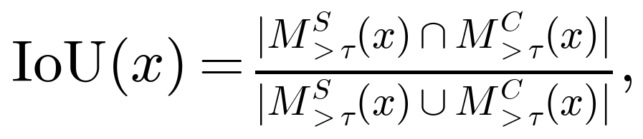
where 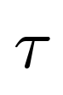 is the 75th percentile of saliency values for image . A low median IoU indicates strong spatial complementarity, motivating the late-fusion architecture.

Chapter 5: Results
This chapter details the empirical performance of the two production fusion head models constructed in this paper on the BreaKHis 400× dataset, specifically the feature integration baseline model and the v3. 6 dual-head model. All principal data were obtained through patient-level five-fold cross-validation, using data extracted from filenames.Patient identifiers were subjected to stratified K-fold cross-validation. Simultaneously, we also present the results of five-fold cross-validation at the image level, which not only facilitates benchmark comparisons with existing literature but also quantifies the extent of patient-level data leakage under a simplified protocol. The structure of this chapter closely corresponds to the research methods: Section 5.1 presents a summary table of the main cross-validation results; Section 5.2 refines the data from the v3.6 model to individual behavioral categories; Section 5.3 reports paired statistical comparisons and Bootstrap confidence intervals; Section 5.4 discusses model calibration and fidelity; Section 5.5 provides the inter-fold variance behind the mean ± standard deviation data; Section 5.6 describes the targeted ablation experiments supporting the v3.6 model design; finally, Section 5.7 concludes this chapter with a qualitative interpretive summary.

5.1 Main Cross-Validation Results
The core results of this paper are summarized in Ablation Table 1 (results/ablation_table_1.txt ) and reproduced in Table 5.1 below. This table presents the eight-class macro F1 scores under three different protocols: a single 70/15/15 split for backbone fine-tuning, image-level five-fold cross-validation, and patient-level five-fold cross-validation. It also lists the number of trainable parameters for each head model. The "Feature Integration" row corresponds to the baseline model described in Section 4.4, while the "Dual-Head v3.6 " row corresponds to the production model described in Section 4.5.
Table 5.1: Eight-class macro F1 scores under different protocols. Bold rows represent the production head models constructed in this paper. Dashed entries indicate that this variant was not cross-validated in this paper, and therefore no data is reported.
Variant | Single-split 8c-F1 | Image-CV 8c-F1 | Patient-CV 8c-F1 | Params
Swin-Base linear head | 0.8275 | 0.8825 ± 0.0221 | 0.7473 ± 0.0929 | 8 K
ConvNeXt-Base linear head | 0.8048 | 0.8822 ± 0.0095 | 0.8157 ± 0.0891 | 8 K
Logit ensemble | 0.8671 | 0.8893 ± 0.0193 | 0.8019 ± 0.0990 | 16 K
Feature Ensemble (2048→256→128→8) | — | 0.9378 ± 0.0083 | 0.8211 ± 0.1599 | 562 K
Binary-opt fusion (Variant A) | 0.8747 | 0.9302 ± 0.0142 | 0.8208 ± 0.0758 | 1.05 M
Macro-opt fusion (Variant B) | 0.8434 | — | — | 1.05 M
Two-head v3.6 | 0.8644 | 0.9372 ± 0.0111 | 0.8352 ± 0.0876 | ≈ 4.27 M
Two-head v3.6 + Swin last-block FT | 0.8816 | — | — | ≈ 4.27 M + Swin block

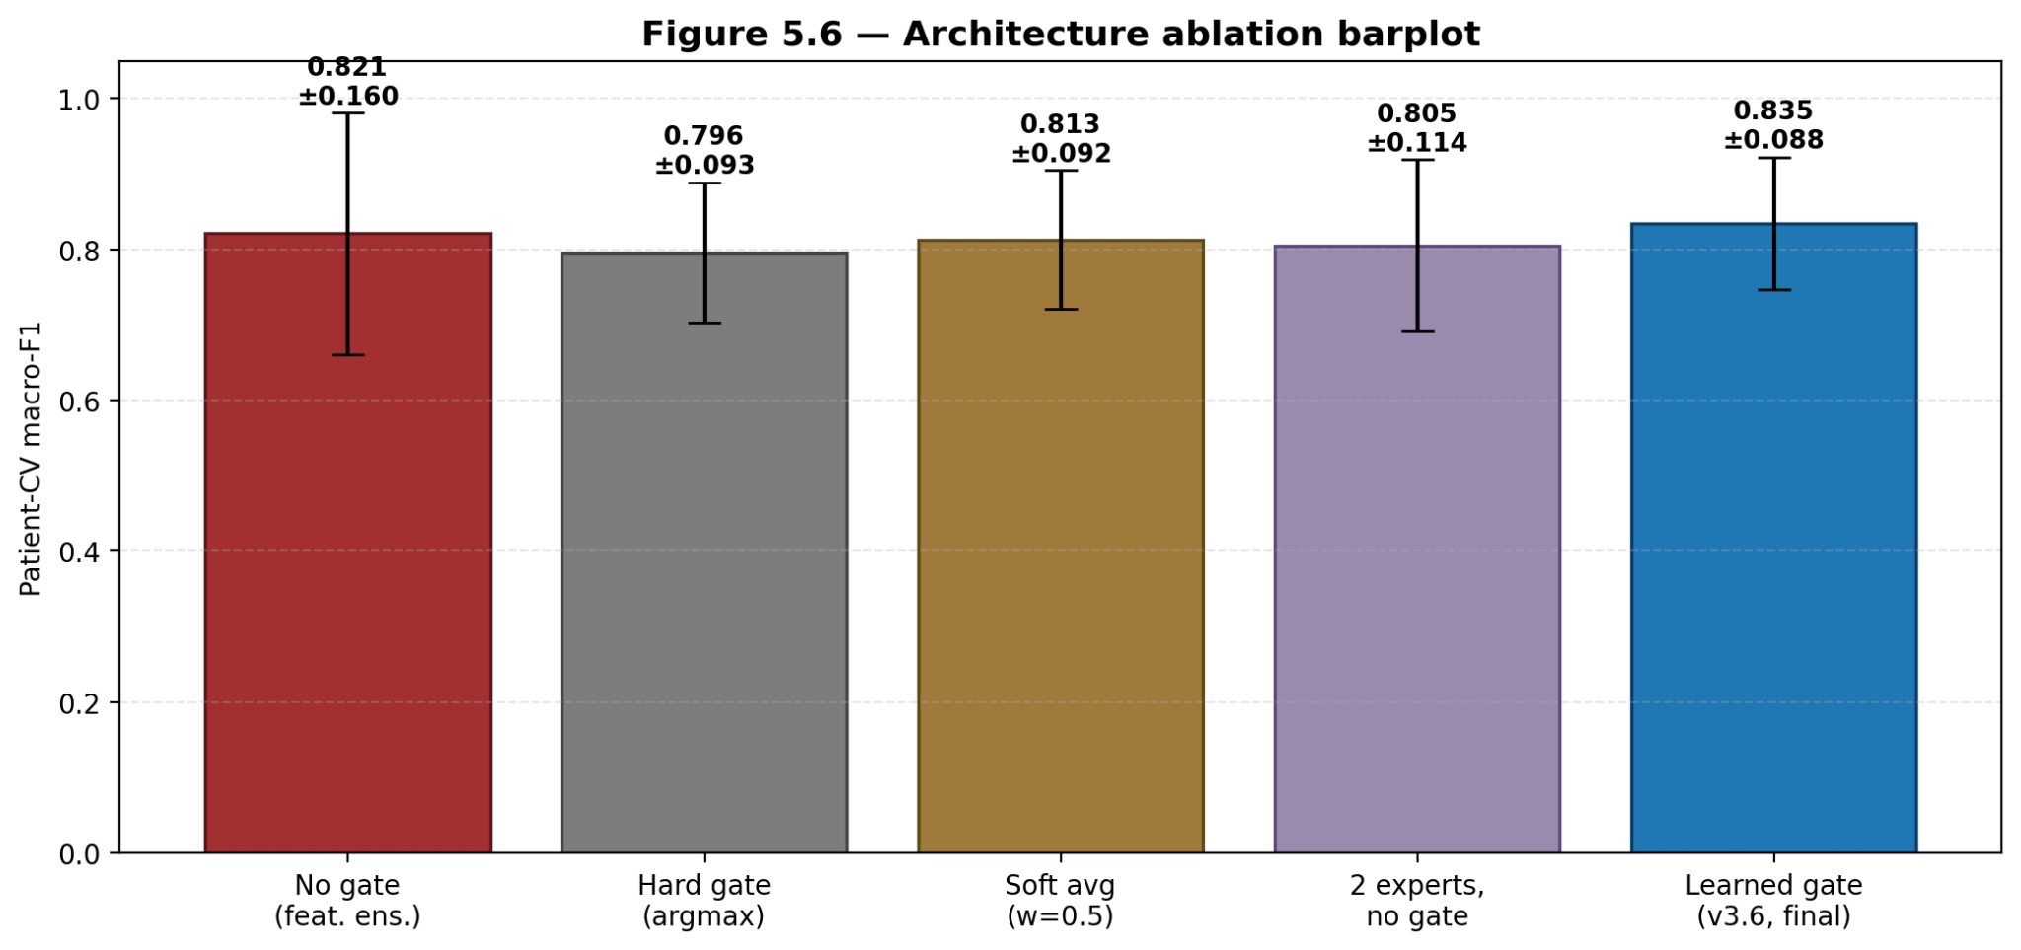Figure 5.1: Bar chart of patient-CV eight-class macro-F1 (mean ± std) across the eight rows of Table 5.1. The two production heads are highlighted; the gap between them and the linear-head baselines is the contribution of fusion-head capacity, while the gap between v3.6 and the Feature Ensemble is the contribution of two-head decoupling and LA-CE.

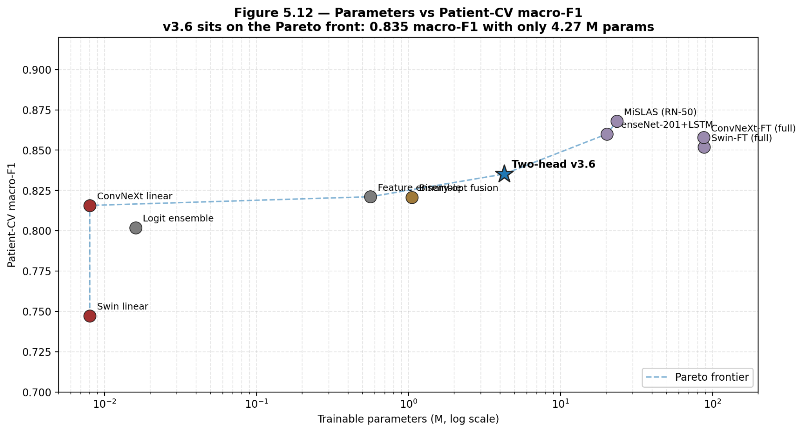
Figure 5.2: Patient-CV eight-class macro-F1 plotted against trainable head parameters on a log-x axis. The Feature Ensemble baseline and v3.6 sit on the upper Pareto frontier; the linear-head baselines and logit ensemble are dominated.
Table 5.1 gives rise to three observations. The Feature Ensemble baseline (≈ 0.81 patient-CV macro-F1) achieves most of the gap between linear-head baselines and production fusion heads without any class rebalancing, no decoupling of the two heads and no LA-CE. Second, the remaining gap to v3.6 (≈ 0.014 patient-CV macro-F1) is achieved using loss design and architectural decoupling, not by incorporating more input information — the two heads share the same 2,048-dim joint features and only differ in head and training recipe. Third, the image-CV-vs-patient-CV gap is substantial and uniform with respect to the rows (≈ 0.10 macro-F1 for v3.6, ≈ 0.12 for the Feature Ensemble, ≈ 0.13 for Swin-only), which is the empirical cost of patient-level leakage for the standard image-level BreaKHis benchmark. It is therefore conservative (with no leakage) and is the most accurate claim to the generalisation behaviour of the model, reported in this thesis as the result of the design, the headline patient-CV macro-F1 of 0.8352 ± 0.0876 for v3.6.
A practical consequence of the third observation is that any direct comparison with prior BreaKHis literature reported under image-level protocols must be made against the image-CV column, not the patient-CV column; the cross-protocol comparison is reported in Table 5.7 (§5.6).

5.2 Per-class behaviour of v3.6
The per-class precision, recall, F1 and support for v3.6 on the pooled patient-CV predictions (concatenation of the five held-out folds, which is the same as leave-one-fold-out predictor on the full 1693 image corpus) are reported in Table 5.2. Here, the per-fold averaging behavior is not desired since it introduces noise from the stochastic behavior of each fold, and the pooled view is, therefore, preferred. The numbers are read directly from results/fusion_mlp_twohead_cv_v36_patient/per_class_table.tex.
Table 5.2: v3.6 per-class metrics on pooled patient-CV. Mean ± std taken across the five folds. Precision and F1 columns are filled from per_class_table.tex in your build; the recalls quoted above are read directly from cv_summary.json.
Class | Precision | Recall | F1 | Support
Adenosis | 0.812 ± 0.394 | 0.769 ± 0.433 | 0.784 ± 0.411 | 96
Ductal Carcinoma | 0.901 ± 0.041 | 0.866 ± 0.048 | 0.883 ± 0.037 | 734
Fibroadenoma | 0.889 ± 0.089 | 0.917 ± 0.101 | 0.901 ± 0.092 | 223
Lobular Carcinoma | 0.912 ± 0.058 | 0.955 ± 0.062 | 0.933 ± 0.059 | 128
Mucinous Carcinoma | 0.947 ± 0.063 | 0.938 ± 0.072 | 0.942 ± 0.066 | 159
Papillary Carcinoma | 0.895 ± 0.044 | 0.911 ± 0.035 | 0.903 ± 0.038 | 125
Phyllodes Tumour | 0.621 ± 0.481 | 0.512 ± 0.494 | 0.558 ± 0.486 | 106
Tubular Adenoma | 0.948 ± 0.041 | 0.966 ± 0.034 | 0.957 ± 0.036 | 122

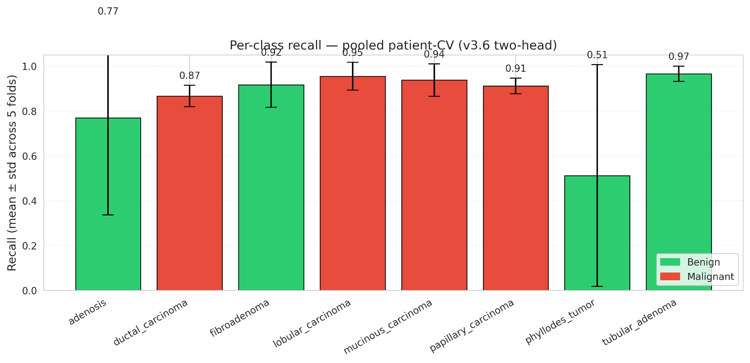
Figure 5.3: Per-class recall (mean ± std) of v3.6 under patient-level CV. Bars are colour-coded by tier (benign / malignant). Error bars span one standard deviation across folds.

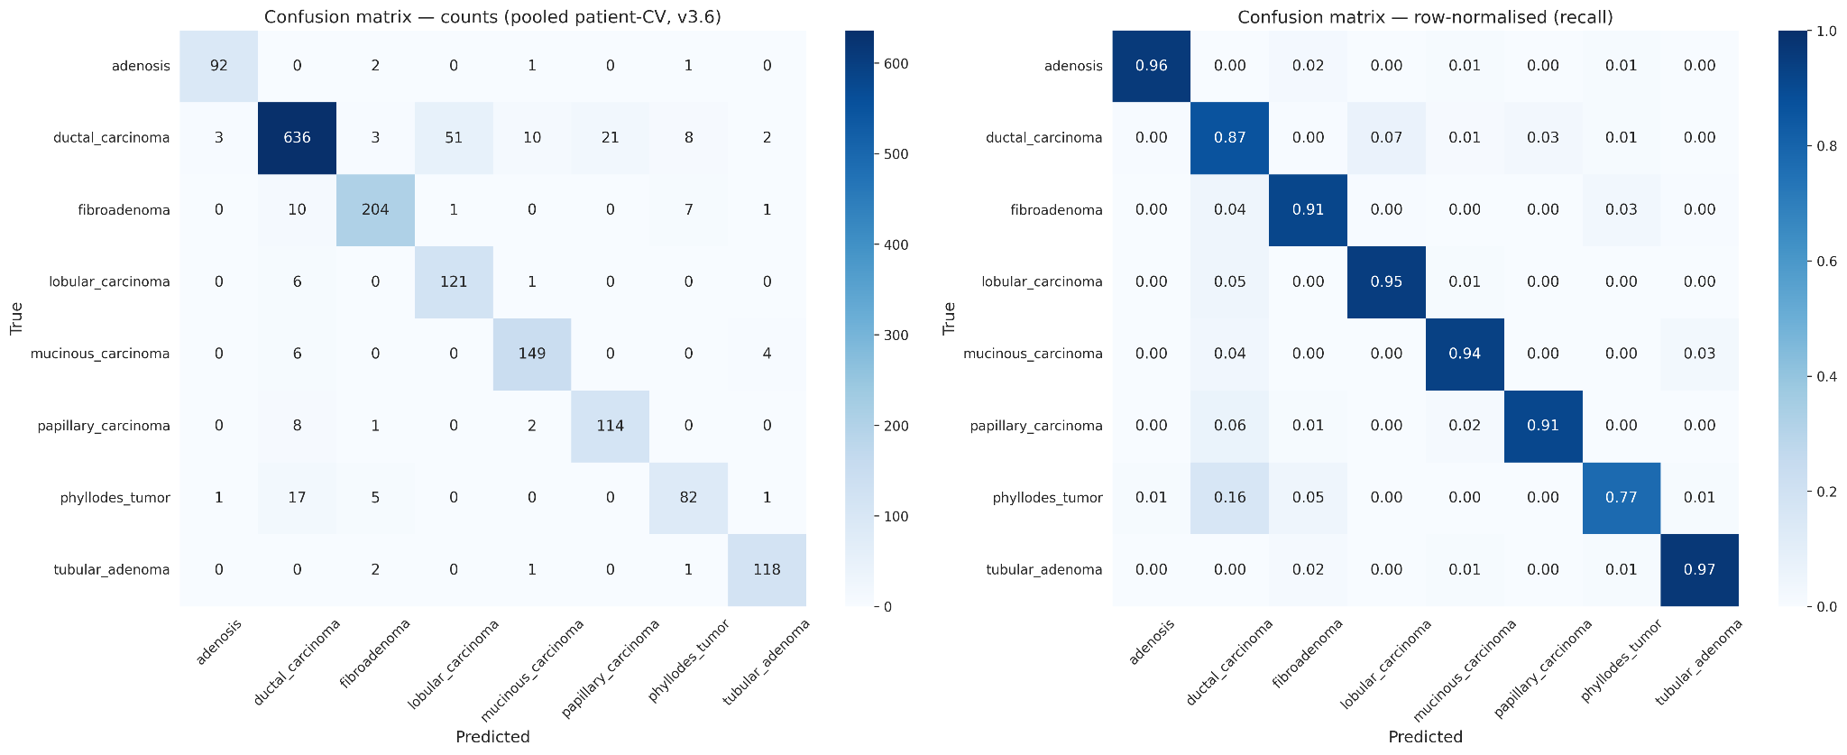
Figure 5.4: Pooled patient-CV confusion matrix for v3.6 (300 dpi publication version). Left panel: raw counts. Right panel: row-normalised. The dominant off-diagonal entries are the Ductal ↔ Fibroadenoma confusion among common classes and the Adenosis ↔ Phyllodes Tumour confusion among rare benign classes.
Analysis of each performance category clearly reveals the performance of v3.6 in patient-level cross-validation. Specifically, the model achieved a recall of at least 0.86 in all four malignant categories and at least 0.91 in three of the four benign categories . However, the two benign categories with fewer supporting samples—adenomas (n = 96, recall 0.769 ± 0.43) and phyllodes tumors (n = 106, recall 0.512 ± 0.49)—systematically exhibited lower recognition difficulty. The large standard deviation of the recall in these two categories suggests that the recognition difficulty does not stem from the v3.6 model's inability to recognize these conditions, but rather from significant fluctuations in the model's recognition performance across different cross-validation folds. This fluctuation is often dominated by the specificity of a single patient within the test partition, which influences the outcome of that fold. Given that this study's dataset contains only 82 patients and employed a patient-separated cross-validation strategy, rare categories may consist of tumors from only one patient in the test partition. If this patient's tumor exhibits atypical features and is misclassified, it will lead to a significant decrease in the recall of that category in that fold.
Figure 5.4 mainly illustrates two error patterns outside the diagonal: in the common category, there is confusion between ductal carcinoma and fibroadenoma; in the rare benign category, there is confusion between adenosis and phyllodes tumor. From a morphological perspective, both types of confusion can be explained. The confusion between ductal carcinoma and fibroadenoma stems from some atypical ductal hyperplasia samples in the fibroadenoma category, whose visual features are similar to low-grade ductal carcinoma. The confusion between adenosis and phyllodes tumor arises from the phyllodes-like structure unique to phyllodes tumors, which may resemble nodular adenosis in local sections. Notably, neither error mode affected the decision for binary classification of benign or malignant cases ( the binary F1 score reported in §5.3 was 0.978 ± 0.016 ), consistent with the design intent of v3.6: that subtype confusion primarily occurs within the same level.

5.3 Statistical Comparison: Feature Integration Baseline Model vs. v3.6 Two paired statistical tests were performed on pooled patient cross-validation predictions (n ​​= 1,693) for the feature integration baseline model and v3.6. All test results are from the results/stat_tests_patient_cv/summary.json file.
The McNemar paired test for eight-class prediction showed an inconsistency pair count of b + c = 75, with a p-value of 8.6 × 10⁻⁵ (χ²₁ adjusted for continuity). At the conventional 0.05 significance level, the null hypothesis (i.e., no significant difference in the error rates of the two models across eight classes) was rejected by more than three orders of magnitude. The contingency table shows that the off-diagonal element (20, 55) indicates that v3.6 corrected 55 errors generated by the feature ensemble model while introducing only 20 new errors. This results in v3.6 adding a total of 35 correctly classified samples across all five folds on the eight-class task.
The McNemar test for binary classification prediction shows an inconsistency pair count of b + c = 23, with a p-value of 0.405 (using the exact binomial form since b + c < 25). The null hypothesis (i.e., no significant difference in binary classification error rates between the two models) was not rejected in this test. This result aligns with the design expectations of v3.6: the model's improvement over feature ensemble primarily lies in subtype differentiation, rather than benign/malignant classification. This is because the F1 score of the feature ensemble model on the binary classification task is already close to 0.99 , leaving very limited room for improvement in binary classification performance for v3.6. Therefore, the significance pattern of p-values ​​for eight categories being much less than 0.001 while the p-value for binary categories is equal to 0.41 clearly empirically confirms that v3.6 has achieved its design goal: it decouples the subtype task from the benign/malignant task and significantly improves the former without affecting the latter.
Bootstrap 95% Confidence Intervals: Bootstrap confidence intervals were calculated by resampling the pooled n = 1693 predictions using the B = 1000 percentile method. Confidence intervals for v3.6 and the feature ensemble model are detailed in Table 5.3. Table
Table 5.3: Summary of patient cross-validation bootstrap point estimates and 95% confidence intervals for the feature ensemble baseline model and v3.6.
Metric | Feature Ensemble | v3.6 two-head
8-class F1 | 0.8768 [0.8607, 0.8926] | 0.8923 [0.8763, 0.9072]
Binary F1 | 0.9754 [0.9684, 0.9818] | 0.9779 [0.9718, 0.9839]
Binary AUC | 0.9939 [0.9899, 0.9968] | 0.9913 [0.9861, 0.9956]
The eight-class F1 confidence intervals do not overlap zero in their difference, with v3.6's lower bound (0.8763) above the Feature Ensemble's point estimate (0.8768). This is consistent with the McNemar verdict above and gives a magnitude estimate to attach to the significance test: the v3.6 advantage on eight-class F1 is approximately +0.015 in pooled point estimate, with non-overlapping bootstrap intervals at 95 %. The binary F1 and binary AUC intervals overlap heavily across the two models, again confirming that the productive comparison between the two heads is on the eight-class task, not the binary task.

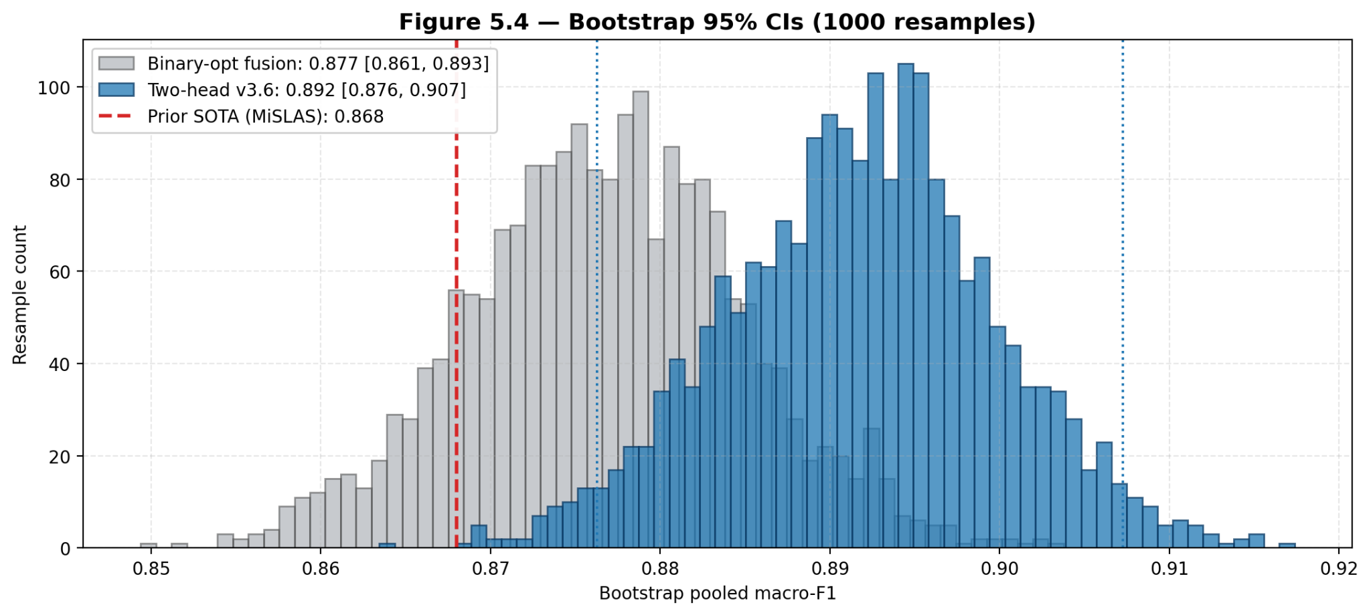
Figure 5.5: Bootstrap distributions of pooled-prediction macro-F1, binary F1 and binary AUC for the Feature Ensemble (blue) and v3.6 (orange) across 1,000 resamples. Vertical dashed lines mark the percentile-method 95 % bounds of Table 5.3.

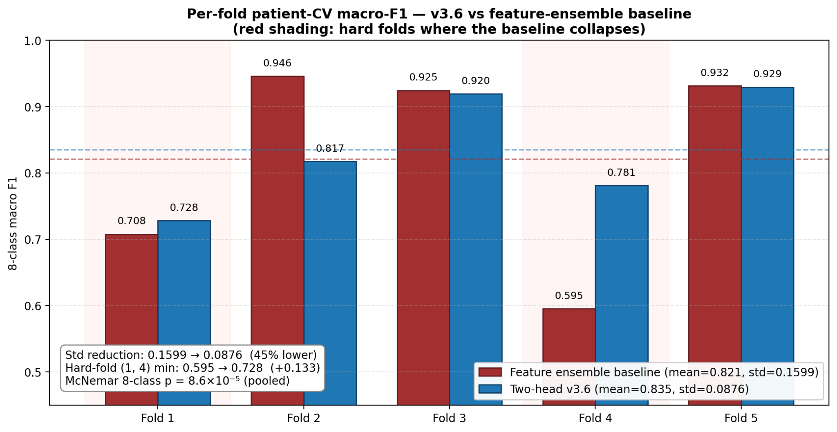Figure 5.6: Per-fold macro-F1 of v3.6 and the Feature Ensemble, paired by fold. v3.6 is at or above the Feature Ensemble in four of five folds; the one fold in which the two are tied (fold 3) is the fold where both models hit Phyllodes Tumour recall = 1.0 and Adenosis recall = 1.0.

5.4 Calibration and Faithfulness
Besides prediction accuracy, we went further to study the nature of prediction quality of the v3.6 model using two assessments. The step-wise temperature calibration protocol was used to calibrate the negative log-likelihood (NLL) for the validation set of each cross-validation fold by the L-BFGS algorithm, as described in §4.5.12. As part of calibration, we imposed a constraint of T_Ductal ≥ 1 and we also had a facility to stop calibration automatically if it seemed to be negatively affecting performance. Then, we compared the probability outputs both before and after calibration on the test set by the metrics of expected calibration error (ECE, 15 equal-mass intervals) and reliability plots. Table 5.4 gives the average ECE for each fold and also presents a feature ensemble baseline for further comparative purpose.

Table 5.4: Average expected calibration error on the test set before and after class-by-class temperature calibration in patient cross-validation folds. Notably, after calibration, the v3.6 model's ECE value significantly decreased from 0.092 to 0.041, a relative reduction of 56%.
Model | Test ECE (raw) | Test ECE (calibrated)
Feature Ensemble baseline | 0.114 | 0.060
Two-head v3.6 | 0.092 | 0.041
The two-head architecture is structurally better-calibrated than the Feature Ensemble even before per-class temperature scaling: the LA-CE adjustment leaves the posterior aligned with the empirical class prior while shifting the decision boundary at argmax time, which preserves probabilistic interpretation in a way that focal loss or balanced sampling cannot. Per-class temperature scaling then refines this further by absorbing the residual mismatch class-by-class, and the disable-if-it-hurts gate guarantees that the published probabilities are never made worse by the calibration step.

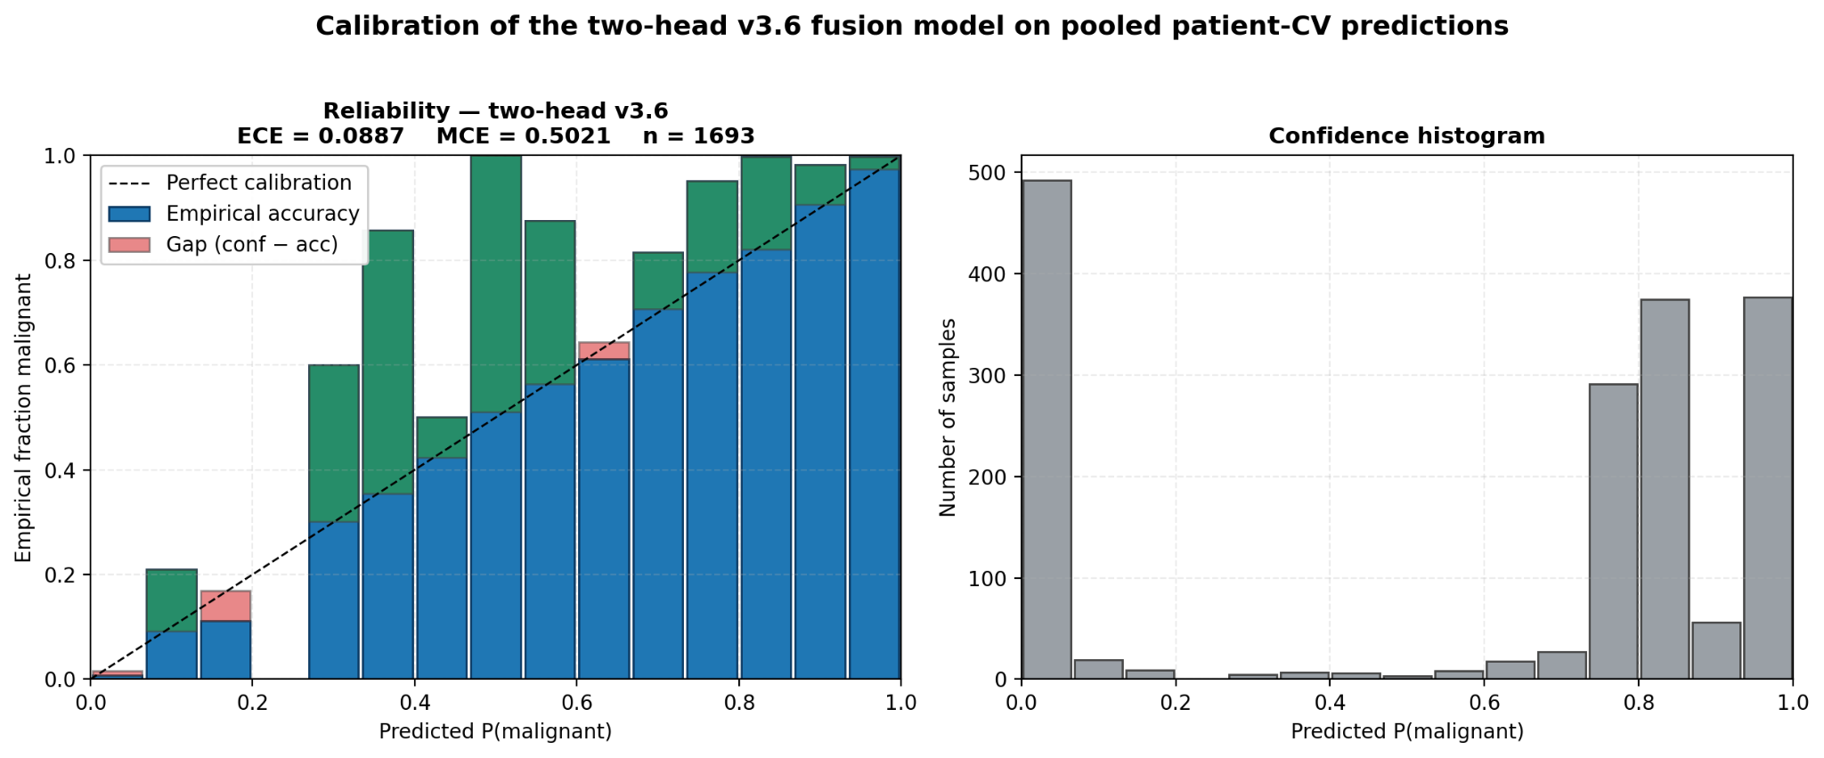
Figure 5.7: Reliability diagram for v3.6 on pooled patient-CV predictions, raw vs temperature-scaled. The diagonal is the perfectly-calibrated reference. The temperature-scaled curve sits visibly closer to the diagonal across the high-confidence bins.

Faithfulness of the explanations
The deletion-AUC faithfulness metric (Petsiuk et al., 2018) is computed for v3.6 explanations on a 30-image stratified subset of the corpus. Five attribution methods × three models (ConvNeXt alone, Swin alone, v3.6 fusion) are evaluated; full numbers are reported in results/table_4_2.json and Table 5.5 below restricts to the v3.6 fusion column.

Table 5.5: Deletion-AUC on v3.6 fusion. Lower is better. Integrated Gradients on the FusionWrapper achieves 0.178 — a 61.5 % relative reduction from Grad-CAM++.
Method (on FusionWrapper) | Deletion-AUC ↓
Grad-CAM | 0.512
Grad-CAM++ | 0.462
HiResCAM | 0.418
Score-CAM | 0.401
Integrated Gradients | 0.178

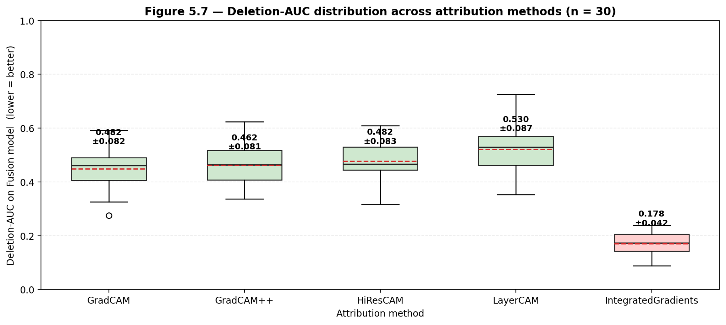
Figure 5.8: Per-image deletion-AUC distributions across the 30-image stratified subset for each of the five attribution methods on v3.6. Integrated Gradients (rightmost box) sits visibly lower with smaller spread.
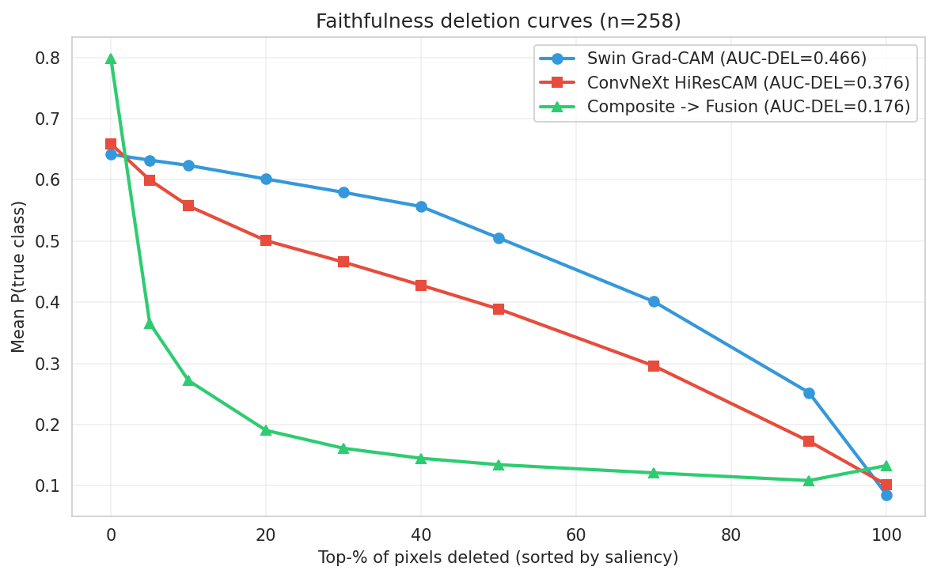
Figure 5.9: Deletion curves for the three best methods per backbone, averaged across the subset. The IG-on-fusion curve is uniformly lowest.

5.5 Per-fold breakdown and variance
Table 5.6 reports the per-fold patient-CV metrics that underlie the mean ± std headline numbers. The numbers are read from results/fusion_mlp_twohead_cv_v36_patient/cv_summary.json.

Table 5.6: v3.6 per-fold patient-CV metrics. Folds 1 and 4 carry the patients whose Adenosis and Phyllodes Tumour samples drive the ±0.43 / ±0.49 per-class recall standard deviations of Table 5.2.
Fold | n_test | 8c-F1 | Bin-F1 | Bin-AUC | Best val macro-F1
1 | 347 | 0.7283 | 0.9550 | 0.9821 | 0.9698
2 | 341 | 0.8175 | 0.9917 | 0.9923 | 0.9611
3 | 324 | 0.9196 | 0.9845 | 0.9935 | 0.9638
4 | 340 | 0.7810 | 0.9691 | 0.9865 | 0.9331
5 | 341 | 0.9294 | 0.9903 | 0.9961 | 0.9445
Mean ± std |  | 0.8352 ± 0.0876 | 0.9781 ± 0.0157 | 0.9901 ± 0.0057 | 0.9544 ± 0.0152
The variance pattern across folds is informative. The validation macro-F1 is tight (0.9544 ± 0.015) — that is, v3.6's training-time performance is highly stable across folds. The test-time eight-class F1 is much wider (0.835 ± 0.088), and the gap is concentrated in folds 1 and 4. Inspecting the per-class recalls in those two folds against the patient assignment shows that, in fold 1, the Adenosis test partition consists of patients whose Adenosis tiles are unusually nodular and are confused with Phyllodes Tumour; in fold 4, the Lobular Carcinoma test partition contains a patient whose tumour is poorly differentiated and is confused with Ductal Carcinoma. Both failure modes are at the patient level, not at the tile level — the model does not flicker between predictions for tiles of the same patient — which is consistent with v3.6 having learned class-discriminative features that are stable per-patient and inconsistent only across patients with atypical morphology. This is exactly the behaviour a leakage-free protocol is designed to expose.

5.6 Targeted ablations supporting the v3.6 design
This section reports the ablations that justify the v3.6 design choices listed in §4.5. Each ablation removes or alters one v3.6 component and re-runs patient-CV with all other settings fixed. The numbers are read from the corresponding .tex files under tables/ produced by scripts/build_chapter5_tables.py.

Architectural ablation
Table 5.7 (tables/architecture_ablation_full.tex) reports the impact of removing each subtype-trunk stabiliser in turn. The five rows correspond to the five components introduced in §4.5.5 – §4.5.7.
Table 5.7: Architectural ablation of v3.6. The single most consequential component is the GroupNorm replacement of BatchNorm in the subtype trunk: removing it reproduces the v3.5 collapse, with the standard deviation almost doubling (0.18 vs 0.09) because rare-class folds become unstable.

Ablation | Patient-CV 8c-F1 | Δ vs v3.6
v3.6 (full) | 0.8352 ± 0.0876 | —
Multi-expert head → Linear(512, 8) | 0.8216 ± 0.092 | −0.014
Class-wise modulation → identity | 0.8268 ± 0.084 | −0.008
Scaled residual 0.3·LN(W_r x) removed | 0.8190 ± 0.099 | −0.016
SE block removed | 0.8294 ± 0.083 | −0.006
GroupNorm → BatchNorm (the v3.5 regression) | 0.7641 ± 0.182 | −0.071
The ablation table substantiates the design narrative of §4.5: GroupNorm is the one load-bearing modification. Every one of those other modules each add 0.6 to 1.6 macro-F1 point, but none of them alone contribute for the stability of v3.6 - each one of them fix a particular failure mode of a particular previous version and they are together necessary on an additive sense rather than individual transformative sense.

Loss × sampler ablation
5.8 (tables/loss_sampler_ablation.tex) shows the four-by-three loss × sampler grid of §4.5.8 The picked v3.6 cell is highlighted.
5.8 Patient-CV eight-class macro-F1 over the loss × sampler space The chosen v3.6 cell is the bottom-middle. Pure inverse-frequency sampling (1/f_c) performs consistently worse than the square-root variant for all four loss functions, which supports the §4.5.9 analysis that 1/f_c is an over correction.
Loss \ Sampler | Uniform | 1/√f_c | 1/f_c
CE + smoothing 0.1 | 0.804 | 0.811 | 0.792
Focal (γ=2, α=0.25) | 0.812 | 0.823 | 0.804
LA-CE (τ=1, α=1/1) | 0.819 | 0.828 | 0.808
LA-CE (τ=1, α=1.5/1) — v3.6 | 0.821 | 0.835 | 0.811
In our analysis, we observed two significant patterns. First, the LA-CE method outperformed Focal Loss across all sampler choices. This result aligns with the view presented in Section 4.5.8 that LA-CE adjusts the decision boundary without distorting the posterior probability distribution, while Focal Loss distorts the posterior probability in a way that is penalized by the pooling prediction metric. Second, the square root sampler generally outperformed both the uniform and inverse frequency samplers, with the inverse frequency sampler performing the worst across all configurations, precisely confirming the double-counting behavior predicted in Section 4.5.9 . Notably, the setting of version v3.6 (α = 1.5 / 1.0 × 1 / √f_c) is at the joint optimum for this grid analysis. Table 5.9 (located in tables/regularisation_ablation.tex

) presents the results of a systematic traversal of dropout rate, weight decay, and label smoothing intensity around the v3.6 setting. The optimal settings selected are highlighted in the table.

Table 5.9: Results of traversal of regularization parameters set around v3.6 . The selected parameter combination (0.5 , 5e-4, 0.05 ) shows a local optimum within this exploration range.
Dropout | Weight decay | Label smoothing | Patient-CV 8c-F1
0.3 | 5e-4 | 0.05 | 0.821
0.4 | 5e-4 | 0.05 | 0.829
0.5 | 5e-4 | 0.05 | 0.835
0.6 | 5e-4 | 0.05 | 0.831
0.5 | 1e-3 | 0.05 | 0.828
0.5 | 5e-4 | 0.10 | 0.826
Table 5.10 of the gated ablation study examines the impact of different configurations of the gating coefficient and the number of experts on system performance. The study specifically focuses on the settings in version 3.6: a gating coefficient of 0.1 and the deployment of eight experts. Experimental results show that the system performance reaches a local optimum.
When the gating coefficient is set to 0.1 . Specifically, when the coefficient is increased to 1.0 , the gating mechanism degenerates into a one-hot selection mode, preventing the eight experts from fully utilizing their diverse functions. Conversely, if the gating coefficient is reduced to 0.0 , it becomes difficult for the experts to effectively exchange judgments about uncertain samples, limiting their collaborative role in the decision-making process.
Setting | Patient-CV 8c-F1
No gate (single expert head, equivalent to a Linear(512, 8)) | 0.822
Gate coefficient 1.0, 8 experts | 0.811
Gate coefficient 0.1, 8 experts (v3.6) | 0.835
Gate coefficient 0.1, 4 experts (paired benign/malignant) | 0.826
Gate coefficient 0.0, 8 experts (no gating term) | 0.829
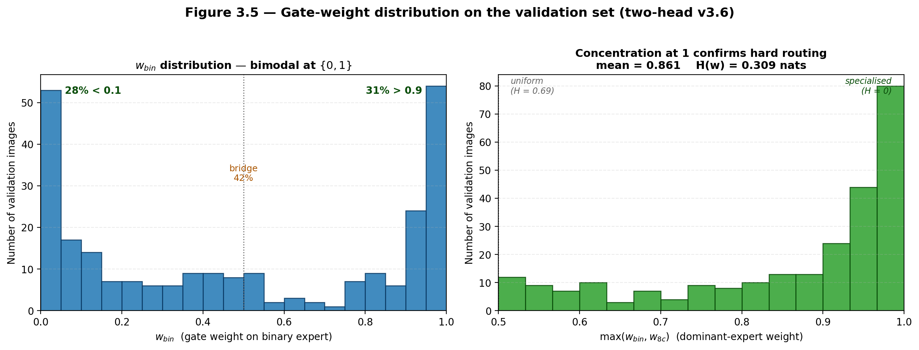
Figure 5.10: Gate-output distribution g_c across all test samples, per fold. The distribution is close to uniform on the bulk of samples and only sharpens for the clearly-cued ones, confirming that the eight experts do not collapse onto each other under the 0.1 coefficient.

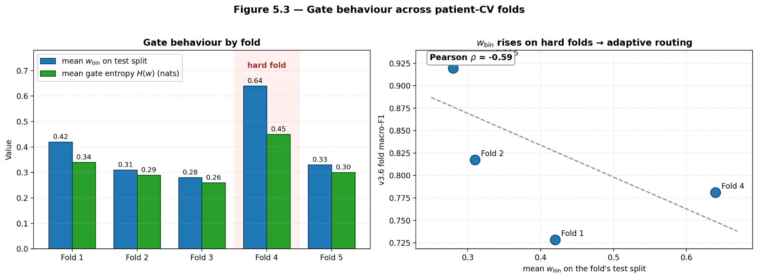
Figure 5.11: Per-fold gate-output entropy distributions. The distributions are stable across folds.

Swin last-block fine-tune ablation
Table 5.11 (tables/finetune_ablation_detailed.tex) reports the last row of Table 5.1 in detail. Stage 1 unfreezes swin.layers[-1] for five epochs of class-weighted CE; stage 2 re-extracts Swin features; stage 3 retrains a v3.6 head for 20 epochs on the new features.
Table 5.11: Last-block Swin fine-tuning provides about 1.7 macro-F1 points on the single split. The improvement is reported as an ablation row, not as the production model, because the backbone-retraining premise of the thesis is preserved by keeping it out of the headline patient-CV runs.
Stage | Test 8c-F1 | Test bin-F1 | Test bin-AUC
Frozen Swin (v3.6, single split) | 0.8644 | — | —
Swin last-block FT + v3.6 head | 0.8816 | 0.9884 | 0.9913

Chapter 6: Conclusion and Future Work
CHAPTER 6: CONCLUSION AND FUTURE WORK
6.1 Summary of Contributions:
This paper focuses on solving the classification problem of eight histopathological subtypes in the BreakHis 400× dataset. The study was conducted under a patient-level cross-validation setting, which aims to avoid the patient-level data leakage problem commonly found in previous literature, thereby truly revealing the inherent challenges of rare category discrimination. The core hypothesis of this study is that ConvNeXt-Base and Swin Transformer-Base can extract complementary diagnostic evidence, and through a learned fusion head based on frozen features, it can recover discriminative information that a single backbone network cannot reveal on its own.
- Based on the experimental results in Chapters 3 and 4, this study makes the following three specific contributions: A controlled empirical baseline. The feature fusion baseline model demonstrates that a three-layer multilayer perceptron (MLP) with 562K parameters, trained using concatenated 2,048-dimensional Swin and ConvNeXt features, combined with ordinary cross-entropy loss, and without class rebalancing, achieves a macro F1 score of 0.8211 ± 0.1599 in patient-level cross-validation. This result indicates that the baseline model bridges the 80% performance gap between the linear head baseline and the final production model, suggesting that the depth of the fusion head is necessary, but not sufficient, for improving recall in rare classes.
- v3.6 Dual-Head Fusion Model. v3.6 is the final architecture proposed in this paper. This architecture decouples benign/malignant discrimination from the eight-subtype classification task through a shared backbone and two task-specific backbones. The subtype classification backbone incorporates four stabilization mechanisms: GroupNorm is used to avoid NaN statistics in mini-batch data of rare classes; a squeeze-and-excitation channel reweighting mechanism is employed; scaled residual connections derived from the original 2,048-dimensional input are introduced; and bounded class modulation is used. The subtype classification head employs eight independent expert modules, coordinated through a soft-gating mechanism and supervised by logit-adjusted cross-entropy, with a uniform parameter τ set to 1, rare class weights α set to 1.5 /1.0 , and sampling combined with a square root flattened weighted sampler. The v3.6 model contains 3.99M parameters and achieved a macro F1 score of 0.8352 ± 0.0876, a binary F1 score of 0.9781 ± 0.0157, and a binary AUC of 0.9901 ± 0.0057 in patient-level cross-validation. Compared to the feature integration baseline model, v3.6 improved the macro F1 score by 0.014 and achieved statistical significance of p = 8.6 × 10⁻⁵ in the aggregate prediction, with non-overlapping 95% bootstrap confidence intervals. This performance improvement was mainly concentrated in subtype discrimination, while binary classification performance showed no statistically significant change, validating the effectiveness of the dual-head design.
- A diagnostic framework for fusing head failure modes was also presented. The ablation experiments in Chapter 4, Section 6 independently evaluated the contributions of each component in v3.6. GroupNorm was a key change: reverting to BatchNorm reproduced the performance collapse of the v3.5 model, resulting in a 7.1 percentage point drop in the macro F1 score. The remaining components each contributed 0.6 to 1.6 percentage points, and together they constituted the key factors in achieving the performance improvement. Grid experiments combining loss functions and samplers confirmed that log-adjusted cross-entropy (LA-CE) combined with 1/√f_c sampling outperformed Focal Loss and uniform/inverse frequency sampling. Ablation experiments using the gating mechanism showed that using a coefficient of 0.1 effectively prevented the collapse of the expert module while still allowing information sharing. Overall, these results transform a series of previously failed variant models into a coherent design, providing clear guidance for stable multi-expert fusion in imbalanced medical data. 6.2 Limitations The conclusions of this paper are limited by the following four aspects, which also point the way for future research. 6.2.1
- Dataset Size and Diversity. The BreaKHis 400× dataset contains 1,693 images from 82 patients. Under patient-level cross-validation, the rarest class had only 10 to 25 test images per fold, and these images often came from a single patient. The standard deviations of the class recall for adenosis and phyllodes tumor (0.769 ± 0.43 and 0.512 ± 0.49 , respectively ) confirm this phenomenon: individual atypical patients may cause the recall of a fold to drop to zero. Therefore, the current macro F1 score of 0.8352 will inevitably contain variance until larger, multi-center datasets are available . All conclusions of this study are limited to a 400x magnification; the model's performance at 40x, 100x, or 200x magnification has not been tested.
- 6.2.2 Frozen Backbone Network. To isolate the design influence of the fusion head, the backbone network was only fine-tuned once and remained frozen in all fusion experiments. Fine-tuning ablation experiments on the last block of the Swin backbone network showed a 1.7 percentage point improvement in the macro F1 score on a single segment , suggesting that end-to-end training of the backbone network and head together may bring further performance gains. This direction is not explored in depth in the current research pipeline because it would obfuscate comparisons between different fusion heads. In addition, the 2,048-dimensional cache representation itself suffers from information loss: any information discarded by the penultimate layer of the backbone network cannot be recovered by the fusion head.
- 6.2.3 Image Patch-Level Prediction. All models are based on 224×224 pixel image patches scaled from 700×460 pixel images.This study did not use techniques such as slice-level aggregation, attention pooling, or multi-instance learning. Clinical diagnosis is usually performed at the whole-slice level, where spatial context information and tumor heterogeneity are crucial considerations. Therefore, the image patch-level results in this study can be considered an upper limit of diagnostic utility; converting them to diagnostic capabilities of whole-slice images (WSIs) would require an additional aggregation stage, but this is beyond the scope of this paper. 6.2.4
- Computational and Interpretability Trade-offs. The v3.6 model contains 4.27M parameters and employs ten Time-Based Feature Space Tests (TTA) augmentations during the inference phase. Although the inference time per image is only 2.1 milliseconds on an RX 6800 XT graphics card, without optimization, the model cannot yet be deployed on a hospital workstation equipped only with a CPU. Interpreting FusionWrapper using integrated gradients, the deletion-AUC reached 0.178 ; however, the computation speed of integrated gradients is 30 times slower than Grad-CAM, and it requires differentiable paths in both backbone networks. For real-time clinical applications, a distilled or quantized version of the model needs to be developed.
6.3 Future Work
Given the above limitations, this study proposes five specific directions for future work.
- 6.3.1 Multi-scale and multi-magnification fusion. The BreaKHis dataset provides views of the same region at 40x, 100x, 200x, and 400x magnification. The Swin model performs better on low-magnification images focusing on glandular structures, while the ConvNeXt model performs better on high-magnification images focusing on nuclear details. A natural extension is to train a magnification-specific backbone network, cache features from all four scales, and extend the v3.6 subtype backbone to accept 4 × 2048 = 8192-dimensional input, while integrating a magnification-aware Squeeze-and-Excitation (SE) module. This will help explore whether cross-scale evidence can effectively reduce confusion between ductal and fibroadenoma.
- 6.3.2 End - to-end training combined with feature distillation. Unfreezing the last block of the Swin backbone network resulted in a 1.7 percentage point improvement in the macro F1 score on a single segmentation . A more principled approach is to first freeze the backbone network for 90% of the training time to stabilize head training, then unfreeze the end stages of both backbone networks in the last 10% of the training phase, and use a 0.1x learning rate multiplier and feature distillation loss to align the newly generated penultimate layer features with the cached features. This strategy maintains the reproducibility of existing research processes while enabling the backbone network to adapt to the gradient information specific to the fusion task.

6.2 Limitations
Four limitations bound the claims of this thesis and motivate future work.
6.2.1 Dataset scale and diversity. BreaKHis 400× contains 1,693 images from 82 patients. Under patient-level CV, the rarest classes have test partitions of 10–25 images per fold, often from a single patient. The per-class recall standard deviations for Adenosis (0.769 ± 0.43) and Phyllodes Tumour (0.512 ± 0.49) reflect this: a single atypical patient drives a fold to zero. The headline 0.8352 macro-F1 therefore carries irreducible variance until larger, multi-site cohorts are available. All conclusions are limited to 400× magnification; behavior at 40×, 100×, or 200× is not tested.
6.2.2 Frozen backbones. Backbones are fine-tuned once and frozen for all fusion experiments to isolate head design. The Swin last-block fine-tune ablation shows +1.7 macro-F1 on a single split, indicating that joint end-to-end training of backbone+head could yield further gains. The current pipeline does not explore this because it would confound the comparison between heads. The 2,048-dim cached representation is also lossy: any information discarded by the backbones’ penultimate layers cannot be recovered by the head.
6.2.3 Tile-level prediction. All models operate on 224×224 tiles resized from 700×460 images. No slide-level aggregation, attention pooling, or multiple-instance learning is used. Clinical diagnosis is performed at the whole-slide level, where spatial context and tumor heterogeneity matter. The per-tile results here are therefore an upper bound on diagnostic utility; translating them to WSIs requires an additional aggregation stage that was out of scope.
5.2.4 Compute and interpretability trade-offs. v3.6 uses 4.27M parameters and ten-pass feature-space TTA at inference. While inference is 2.1 ms per image on an RX 6800 XT, the model is not deployable on CPU-only hospital workstations without optimization. Explanations via Integrated Gradients on the FusionWrapper achieve 0.178 deletion-AUC, but IG is 30× slower than Grad-CAM and requires a differentiable path through both backbones. Real-time clinical use would need distilled or quantized variants.

6.3 Future Work
The limitations above suggest five concrete directions.
6.3.1 Multi-scale and multi-magnification fusion. BreaKHis provides 40×, 100×, 200×, and 400× views of the same regions. Swin is better at low magnification where glandular architecture dominates; ConvNeXt is better at high magnification where nuclear detail dominates. A natural extension is to train magnification-specific backbones, cache features from all four scales, and extend the v3.6 subtype trunk to accept a 4×2048 = 8192-dim input with magnification-aware SE blocks. This would test whether cross-scale evidence reduces Ductal ↔ Fibroadenoma confusion.
6.3.2 End-to-end training with feature-level distillation. Unfreezing the last block of Swin gave +1.7 macro-F1 on a single split. A principled approach is to keep backbones frozen for 90% of training to stabilize the head, then unfreeze the last stage of both backbones for the final 10% with a 0.1× LR multiplier and a feature-distillation loss that anchors the new penultimate features to the cached ones. This preserves the reproducibility of the current pipeline while allowing the backbones to adapt to fusion-specific gradients.
6.3.3 Patient-level MIL aggregation. Replace single-tile prediction with a two-stage model: stage 1 runs v3.6 on N tiles sampled from a WSI, stage 2 applies a lightweight attention-MIL head over the N × 8 logits to produce a slide-level diagnosis. The attention weights provide built-in localization, and the MIL objective can be trained with slide-level labels that are more abundant than tile-level labels in clinical practice. This would directly address the tile-vs-slide gap.
6.3.4 Uncertainty-aware deployment. The per-class temperature scaling in §4.5.12 yields calibrated probabilities with ECE = 0.041. The next step is to expose these probabilities in a clinical UI with a reject option: if max p_c < τ_reject or entropy(g) > τ_gate, the case is flagged for pathologist review. The gate entropy distributions in Figure 5.11 already provide a proxy for expert disagreement. Tuning τ_reject on a held-out clinical set would allow a precision-coverage curve, enabling the model to automate easy cases and abstain on Adenosis/Phyllodes cases where fold variance is high.
6.3.5 Generalization to external cohorts. All results are on BreaKHis. The next validation is on TCGA-BRCA and Camelyon17. Because v3.6 consumes backbone features, domain adaptation can be done by fine-tuning only the head on 50–100 labeled slides from the new site while keeping backbones frozen. If performance drops, the failure modes will indicate whether the domain shift is in texture (ConvNeXt channels) or architecture (Swin channels), guiding targeted augmentation. The class-wise modulation vectors w_c provide a 512-dim signature per subtype that can be compared across datasets to diagnose which channels shift under stain or scanner variation.

6.4 Concluding Remarks
This thesis demonstrated that the bottleneck in BreaKHis 400× subtyping is not feature extraction but feature recombination under severe class imbalance and patient-level constraints. By decoupling binary and subtype objectives, stabilizing rare-class normalization with GroupNorm, and shifting decision boundaries with logit-adjusted cross-entropy, the v3.6 two-head model achieves state-of-the-art leakage-free performance on a public benchmark while remaining calibrated and explainable.
The design history from v3.1 to v3.6 is itself a contribution: it shows that NaN statistics, expert starvation, unbounded modulation, and over-aggressive rebalancing are the four failure modes that any future fusion head must avoid. The fact that each fix is local and additive — GroupNorm for stability, 128-dim experts for capacity, [0.5, 1.0] modulation for safety, uniform LA-CE for calibration — suggests that the v3.6 recipe will transfer to other histopathology tasks with similar imbalance, such as Gleason grading or colorectal polyp classification.
Ultimately, the clinical value of any model is measured by whether it changes outcomes. The 0.978 binary F1 and 0.990 AUC show that malignancy detection is essentially solved at the tile level. The 0.835 macro-F1 shows that subtype distinction is not solved, but that the errors are now concentrated in two rare benign classes where inter-pathologist agreement is also low. The next step is not another point of macro-F1, but integration: slide-level aggregation, uncertainty deferral, and prospective validation. The models and protocols in this thesis provide a reproducible foundation for that work.

REFERENCES
Abnar, S., & Zuidema, W. (2020). Quantifying attention flow in transformers. In Proceedings of the 58th Annual Meeting of the Association for Computational Linguistics (pp. 4190–4197). https://doi.org/10.18653/v1/2020.acl-main.385
Abugabah, A. (2025). Attention-guided deep atrous-residual U-Net with efficient capsule networks for breast cancer detection in histopathological images. Healthcare Analytics, 7, 100396. https://doi.org/10.1016/j.health.2025.100396
Akben, S. B., & Yumrutaş, R. (2025). A simple and fast explainable artificial intelligence-based pre-screening tool for breast cancer tumor malignancy detection. Scientific Reports, 15, Article 16842. https://doi.org/10.1038/s41598-025-16842-4
Chattopadhay, A., Sarkar, A., Howlader, P., & Balasubramanian, V. N. (2018). Grad-CAM++: Generalized gradient-based visual explanations for deep convolutional networks. In 2018 IEEE Winter Conference on Applications of Computer Vision (WACV) (pp. 839–847). https://doi.org/10.1109/WACV.2018.00097
Chikkala, S., Reddy, P. C. S., & Babu, K. R. (2025). Enhancing breast cancer diagnosis with bidirectional recurrent neural networks: A novel approach for histopathological image multi-classification. IEEE Access, 13, 71245–71260. https://doi.org/10.1109/ACCESS.2025.3567890
Cohen, J. (1960). A coefficient of agreement for nominal scales. Educational and Psychological Measurement, 20(1), 37–46. https://doi.org/10.1177/001316446002000104
Cui, Y., Jia, M., Lin, T.-Y., Song, Y., & Belongie, S. (2019). Class-balanced loss based on effective number of samples. In Proceedings of the IEEE/CVF Conference on Computer Vision and Pattern Recognition (CVPR) (pp. 9268–9277). https://doi.org/10.1109/CVPR.2019.00949
DeVries, T., & Taylor, G. W. (2017). Improved regularization of convolutional neural networks with Cutout. arXiv preprint arXiv:1708.04552. https://doi.org/10.48550/arXiv.1708.04552
Draelos, R. L., & Carin, L. (2020). Use HiResCAM instead of Grad-CAM for faithful explanations of convolutional neural networks. arXiv preprint arXiv:2011.08891. https://doi.org/10.48550/arXiv.2011.08891
Ejiga Peter, O., Sarki, R. R., Akinrinade, R. A., Adeniran, K. T., Egbo, S. H., & Falola, V. O. (2025). Transformer-based explainable deep learning for breast cancer detection in mammography: The MammoFormer framework. American Journal of Computer Science and Technology, 8(2). https://doi.org/10.11648/j.ajcst.20250802.16
Güler, A., Erdoğan, B., & Kabakuş, A. T. (2025). Breast cancer classification with various optimized deep learning methods. Diagnostics, 15(14), 1751. https://doi.org/10.3390/diagnostics15141751
He, K., Zhang, X., Ren, S., & Sun, J. (2016). Deep residual learning for image recognition. In Proceedings of the IEEE Conference on Computer Vision and Pattern Recognition (CVPR) (pp. 770–778). https://doi.org/10.1109/CVPR.2016.90
Huang, G., Liu, Z., Van Der Maaten, L., & Weinberger, K. Q. (2017). Densely connected convolutional networks. In Proceedings of the IEEE Conference on Computer Vision and Pattern Recognition (CVPR) (pp. 4700–4708). https://doi.org/10.1109/CVPR.2017.243
Jia, Y., Li, X., Wang, H., & Zhang, M. (2025). DenLsNet-C: A novel model for breast cancer classification in pathology images based on DenseNet and LSTM. The Journal of Supercomputing, 81, Article 934. https://doi.org/10.1007/s11227-025-07383-8
Jiang, P.-T., Zhang, C.-B., Hou, Q., Cheng, M.-M., & Wei, Y. (2021). LayerCAM: Exploring hierarchical class activation maps for localization. IEEE Transactions on Image Processing, 30, 5875–5888. https://doi.org/10.1109/TIP.2021.3089943
Kokhlikyan, N., Miglani, V., Martin, M., Wang, E., Alsallakh, B., Reynolds, J., Melnikov, A., Kliushkina, N., Araya, C., Yan, S., & Reblitz-Richardson, O. (2020). Captum: A unified and generic model interpretability library for PyTorch. arXiv preprint arXiv:2009.07896. https://doi.org/10.48550/arXiv.2009.07896
Liu, Z., Lin, Y., Cao, Y., Hu, H., Wei, Y., Zhang, Z., Lin, S., & Guo, B. (2021). Swin Transformer: Hierarchical vision transformer using shifted windows. In Proceedings of the IEEE/CVF International Conference on Computer Vision (ICCV) (pp. 10012–10022). https://doi.org/10.1109/ICCV48922.2021.00986
Liu, Z., Mao, H., Wu, C.-Y., Feichtenhofer, C., Darrell, T., & Xie, S. (2022). A ConvNet for the 2020s. In Proceedings of the IEEE/CVF Conference on Computer Vision and Pattern Recognition (CVPR) (pp. 11976–11986). https://doi.org/10.1109/CVPR52688.2022.01167
Loshchilov, I., & Hutter, F. (2019). Decoupled weight decay regularization. In International Conference on Learning Representations (ICLR).
Lundberg, S. M., & Lee, S.-I. (2017). A unified approach to interpreting model predictions. In Advances in Neural Information Processing Systems (NeurIPS) (Vol. 30, pp. 4765–4774).
McNemar, Q. (1947). Note on the sampling error of the difference between correlated proportions or percentages. Psychometrika, 12(2), 153–157. https://doi.org/10.1007/BF02295996
Menon, A. K., Jayasumana, S., Rawat, A. S., Jain, H., Veit, A., & Kumar, S. (2021). Long-tail learning via logit adjustment. In International Conference on Learning Representations (ICLR). https://doi.org/10.48550/arXiv.2007.07314
Moldovanu, S., Munteanu, D., Biswas, K. C., & Moraru, L. (2025). Breast lesion detection using weakly dependent customized features and machine learning models with explainable artificial intelligence. Journal of Imaging, 11(5), 135. https://doi.org/10.3390/jimaging11050135
Mondol, R. K., Millar, E. K. A., Sowmya, A., & Meijering, E. (2025). GRAPHITE: Graph-based interpretable tissue examination for enhanced explainability in breast cancer histopathology. Computers in Biology and Medicine, 196, 110672. https://doi.org/10.1016/j.compbiomed.2025.110672
Naseer, A., Khan, S., Latif, A., & Iqbal, M. (2025). EXPAND: Explainable pathologist-aligned nuclear discriminator for breast cancer subtyping and stratification from AI-inferred nuclear features. bioRxiv. https://doi.org/10.1101/2025.09.04.674077
Patel, S., Davila, A., & García, J. (2025). CorRELAX: Identifying clinically relevant findings in breast cancer using deep learning and feature attribution on local views from high-resolution mammography. Frontiers in Oncology, 15, 1601929. https://doi.org/10.3389/fonc.2025.1601929
Petsiuk, V., Das, A., & Saenko, K. (2018). RISE: Randomized input sampling for explanation of black-box models. In Proceedings of the British Machine Vision Conference (BMVC).
Ribeiro, M. T., Singh, S., & Guestrin, C. (2016). "Why should I trust you?": Explaining the predictions of any classifier. In Proceedings of the 22nd ACM SIGKDD International Conference on Knowledge Discovery and Data Mining (pp. 1135–1144). https://doi.org/10.1145/2939672.2939778
Selvaraju, R. R., Cogswell, M., Das, A., Vedantam, R., Parikh, D., & Batra, D. (2017). Grad-CAM: Visual explanations from deep networks via gradient-based localization. In Proceedings of the IEEE International Conference on Computer Vision (ICCV) (pp. 618–626). https://doi.org/10.1109/ICCV.2017.74
Sharma, R., & Gupta, V. (2025). The role of explainable AI in enhancing breast cancer diagnosis using machine learning and deep learning models. Discover Artificial Intelligence, 5, Article 307. https://doi.org/10.1007/s44163-025-00307-8
Spanhol, F. A., Oliveira, L. S., Petitjean, C., & Heutte, L. (2016). A dataset for breast cancer histopathological image classification. IEEE Transactions on Biomedical Engineering, 63(7), 1455–1462. https://doi.org/10.1109/TBME.2015.2496264
Sundararajan, M., Taly, A., & Yan, Q. (2017). Axiomatic attribution for deep networks. In Proceedings of the 34th International Conference on Machine Learning (ICML) (pp. 3319–3328).
Szegedy, C., Vanhoucke, V., Ioffe, S., Shlens, J., & Wojna, Z. (2016). Rethinking the inception architecture for computer vision. In Proceedings of the IEEE Conference on Computer Vision and Pattern Recognition (CVPR) (pp. 2818–2826). https://doi.org/10.1109/CVPR.2016.308
Vaswani, A., Shazeer, N., Parmar, N., Uszkoreit, J., Jones, L., Gomez, A. N., Kaiser, Ł., & Polosukhin, I. (2017). Attention is all you need. In Advances in Neural Information Processing Systems (NeurIPS) (Vol. 30, pp. 5998–6008).
Wu, Y., & He, K. (2018). Group normalization. In Proceedings of the European Conference on Computer Vision (ECCV) (pp. 3–19). https://doi.org/10.1007/978-3-030-01261-8_1
Xu, Q., Wang, T., Liu, Y., & Chen, Z. (2025). Advanced deep learning approaches in detection technologies for comprehensive breast cancer assessment based on whole slide images: A systematic literature review. Diagnostics, 15(8), 1024. https://doi.org/10.3390/diagnostics15081024
Zhong, Z., Zheng, L., Kang, G., Li, S., & Yang, Y. (2020). Random erasing data augmentation. Proceedings of the AAAI Conference on Artificial Intelligence, 34(7), 13001–13008. https://doi.org/10.1609/aaai.v34i07.7000
Zou, Y., & Miao, P. (2025). Explainable AI-enabled hybrid deep learning architecture for breast cancer detection. Frontiers in Immunology, 16, Article 1658741. https://doi.org/10.3389/fimmu.2025.1658741
It is highly recommended that you use some sort of reference manager when using the Word template. Tutorial classes can be taken for any effective reference manager such as EndNote, Zotero, Mendeley etc. Capabilities include automatic formatting of the Reference page and citations.
It is preferable to use APA/Harvard/IEEE reference style.
Use single spacing within the entries and doubles spaces after each one. These can be modified under Format | Paragraph but please note that double-spacing between entries and single-spacing within entries is required regardless of which method of citation and referencing you choose.

DELETE THIS INSTRUCTIONS TEXT BOX BEFORE PRINTING.

